Introduction

https://www.youtube.com/watch?v=9jA0KjS7V_c&list=PLZoTAELRMXVPGU70ZGsckrMdr0FteeRUi

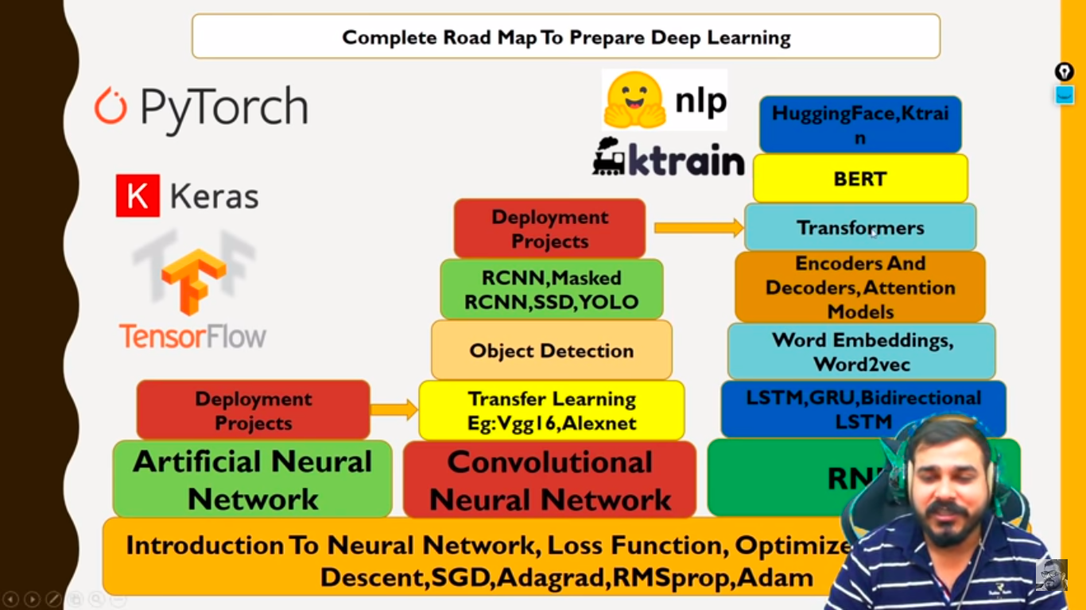
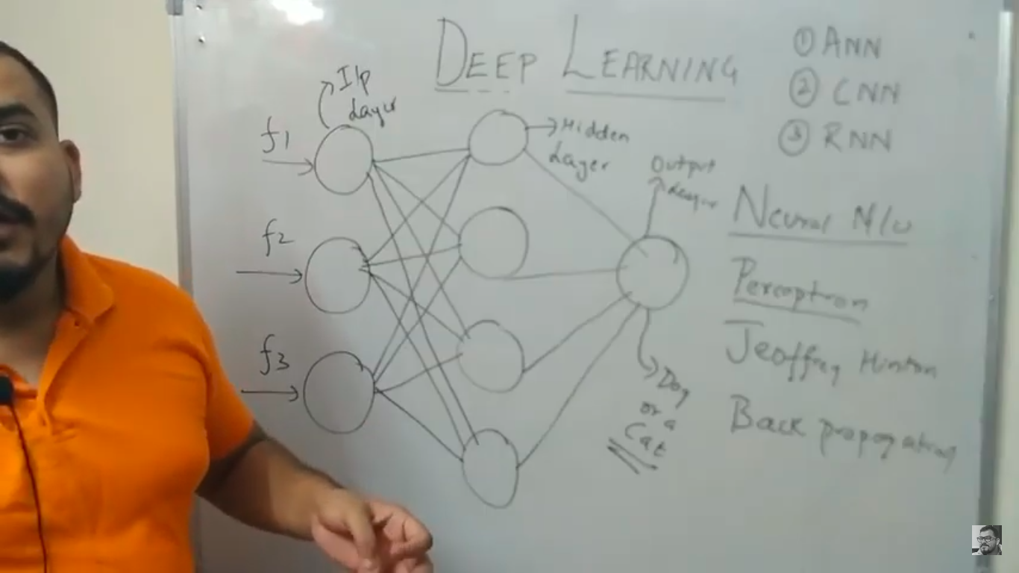

How Neural Networks work
Weights and activation function(Z=Act(y)) plays major role. Eg: If hot object is placed in right hand, only neurons in right hand(RH) will be activated but rest of the neurons in left hand(LH) won’t be activated. RH neurons will get higher weight compared to LH neurons. We calculate step 1 & step 2 in hidden layer Neuron.

Activation Function(AF) decides whether neurons needs to be activated (or) not. E.g: Sigmoid AF(Logistic Regression) ranges from 0 to 1. If AF<0.5, then neuron is deactivated else activated. AF(Z) is then multiplied with weight(W4) and then another AF is applied to Z to get the o/p.

In this case, we have taken only 1 neuron. It can be any no. Of Neuron.

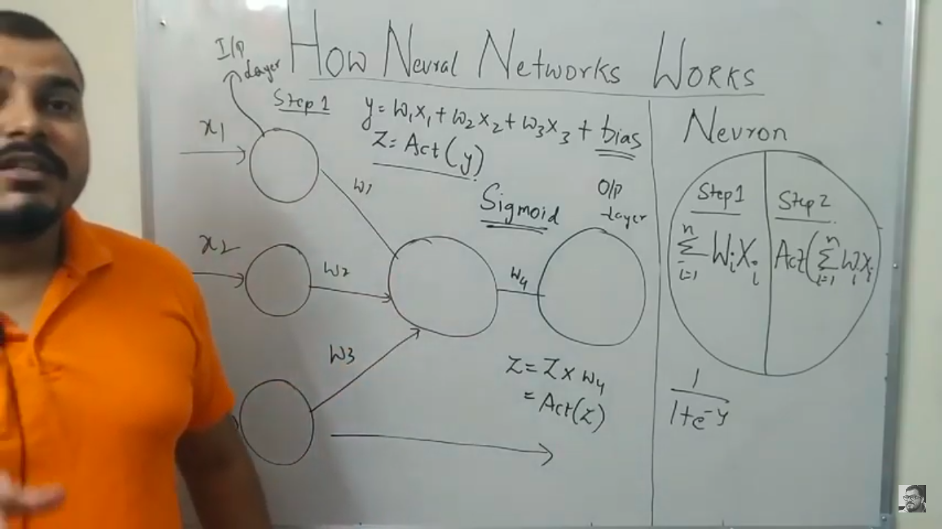
Types of Activation Function(AF)
https://missinglink.ai/guides/neural-network-concepts/7-types-neural-network-activation-functions-right/
https://www.analyticsvidhya.com/blog/2020/01/fundamentals-deep-learning-activation-functions-when-to-use-them/

Binary Step Function
If the input to the activation function is greater than a threshold, then the neuron is activated, else it is deactivated, i.e. its output is not considered for the next hidden layer.
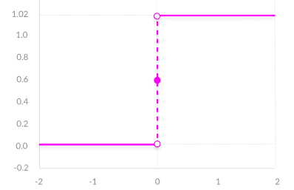
f(x) = 1, x>=0
= 0, x<0
Drawbacks
The binary step function can be used as an activation function while creating a binary classifier. As you can imagine, this function will not be useful when there are multiple classes in the target variable. That is one of the limitations of binary step function.

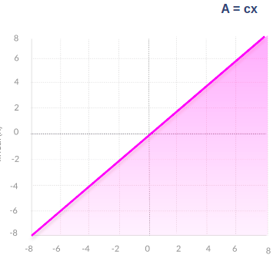
Linear Function
It takes the inputs, multiplied by the weights for each neuron, and creates an output signal proportional to the input. In one sense, a linear function is better than a step function because it allows multiple outputs, not just yes and no.
f(x)=ax
f'(x) = a(derivate of f(x))

Drawbacks

- Not possible to use backpropagation(gradient descent) to train the model
- All layers of the neural network collapse into one - with linear activation functions, no matter how many layers in the neural network, the last layer will be a linear function of the first layer (because a linear combination of linear functions is still a linear function). So a linear activation function turns the neural network into just one layer. Although the gradient here does not become zero, but it is a constant which does not depend upon the input value x at all. This implies that the weights and biases will be updated during the backpropagation process but the updating factor would be the same. Derivate(dy/dx) of ‘ax’ is ‘a’ which is constant, so weight and bias won’t updated based on input(x). Wold=Wnew

Non-Linear Activation Functions
Modern neural network models use non-linear activation functions. They allow the model to create complex mappings between the network’s inputs and outputs, which are essential for learning and modeling complex data, such as images, video, audio, and data sets which are non-linear or have high dimensionality.
They allow backpropagation because they have a derivative function which is related to the inputs. They allow “stacking” of multiple layers of neurons to create a deep neural network. Multiple hidden layers of neurons are needed to learn complex data sets with high levels of accuracy.

All non-linear AF types are available under Activation Functions(AF))

Activation Functions(AF)
Also available in TensorFlow-Udemy.odt in /home/vinoth/Learning/Python path
https://towardsdatascience.com/activation-functions-neural-networks-1cbd9f8d91d6
https://www.analyticsvidhya.com/blog/2020/01/fundamentals-deep-learning-activation-functions-when-to-use-them/
https://missinglink.ai/guides/neural-network-concepts/7-types-neural-network-activation-functions-right/

Threshold AF
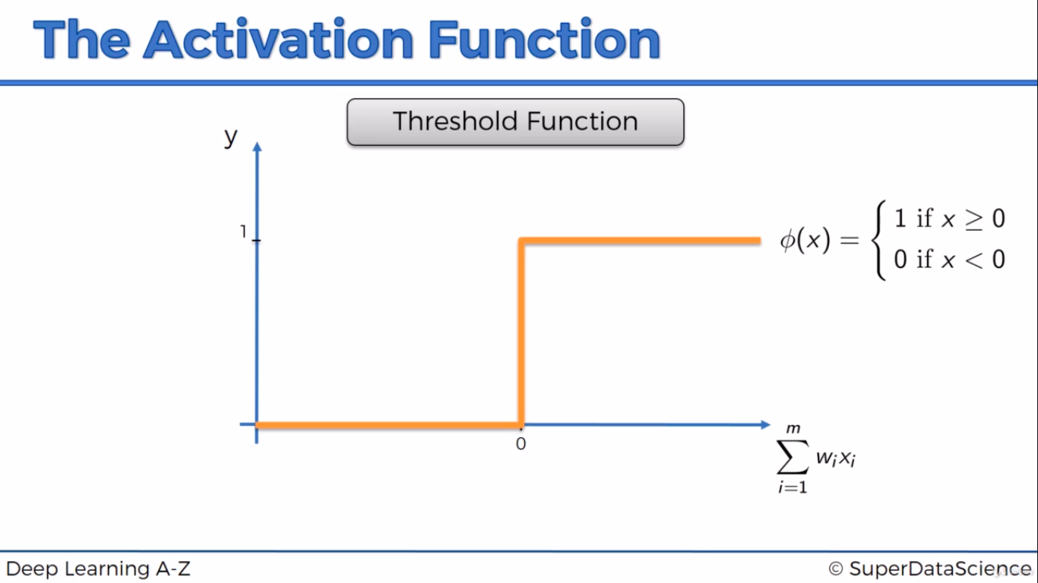

Sigmoid AF
Convert any value between 0 to 1. Any value < 0.5 is 0 else its 1.
0 – Neuron won’t be activated, 1 – Neuron will be activated. Derivative of sigmoid AF is 0 to 0.25
AF = 1/(1+e^-y)
It is used in Classification algoritm where we will get o/p as either 0 or 1
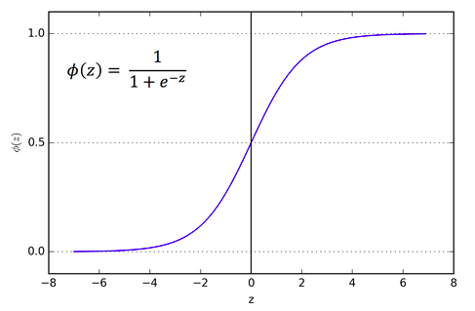
Sigmoid AF isn’t zero centric(normal) distribution. So it takes time for sigmoid AF to converge in global minima

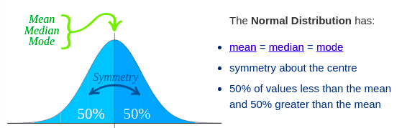

Hyperbolic Tangent(tanh) (or) Threshold AF
Range is -1 to 1. Derivative is 0 to 1.
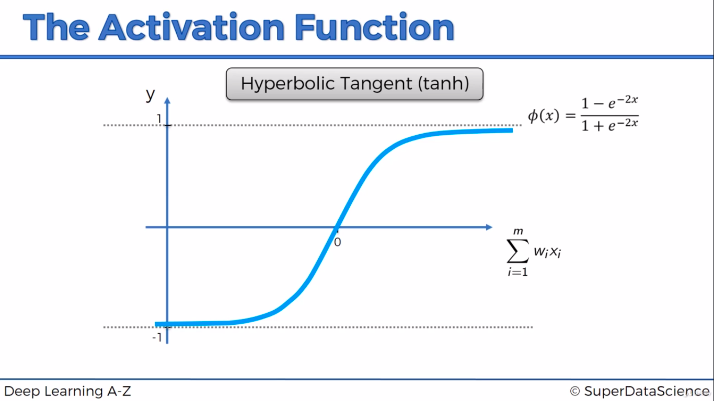
Sigmoid & tanh causes Vanishing Gradient Problem

ReLU(Rectified Linear Unit) AF
Max(0,z) ==> 0 if z<0 & z if z > 0
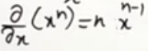
If y is negative, then it returns 0. If y=5 then max(5,0) =5. Derivative of constant is 0 if Z<0 or 1 if Z>0 since tan 45(degree) is 1. In Multilayer Neural Network, if derivative returns 0 then product of derivative of all layer becomes 0, then Wnew=Wold which causes dead neuron & it won’t converge to global minima. This is called Dead Activation or Dying ReLU. It can be fixed using Leaky ReLU
Derivative of 0 is 0 if Z<0. Derivative of Z is 1 if Z>0
It is used in Regression algoritm. Derivative is either 0 or 1
f'(x) = 1, x>=0 (derivative)
= 0, x<0
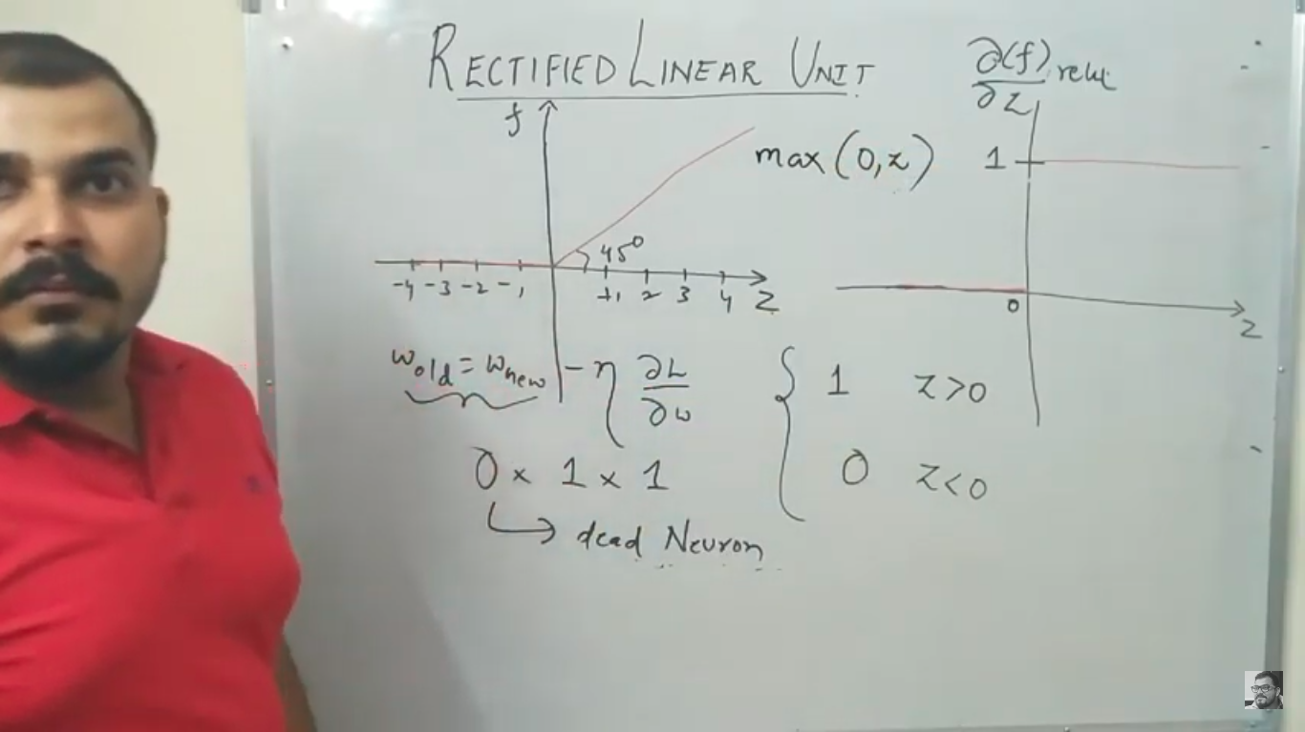

Leaky ReLU
It is an attempt to solve the dying ReLU problem
The leak helps to increase the range of the ReLU function. Usually, the value of a is 0.01 or so.
f(x)= 0.01x, x<0
= x, x>=0
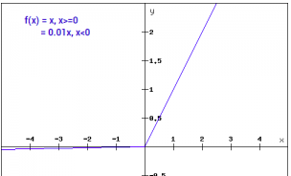
By making this small modification, the gradient of the left side of the graph comes out to be a non zero value. Hence we would no longer encounter dead neurons in that region. Here is the derivative of the Leaky ReLU function

f'(x) = 1, x>=0 (derivative)
=0.01, x<0

Since it return 0.01 & in MNN, derivative will return smaller value where Wnew=Wold which caused Vanishing Gradient Problem
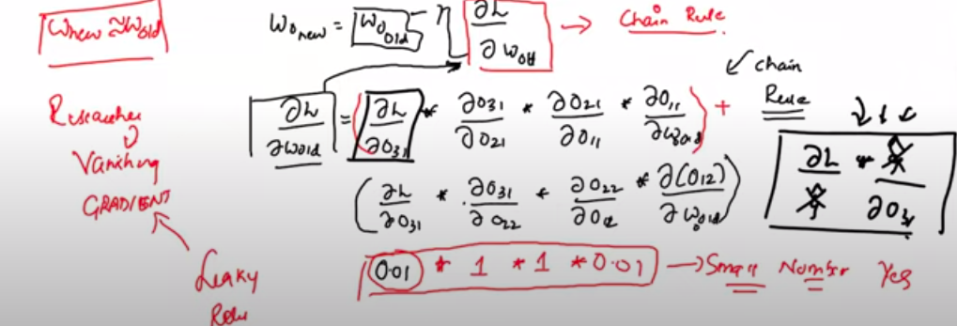

Parameterised ReLU
If a is 0.01 then its Leaky ReLU. If a is 0 then its ReLU AF.
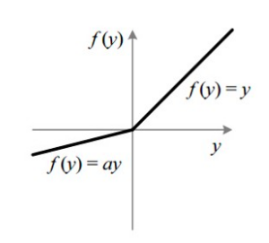
f(x) = x, x>=0
= ax, x<0
f'(x) = 1, x>=0
= a, x<0
f'(x) – derivative (or) gradient

ELU (Exponential Linear Units)
Derivative of 0 isn’t available in ELU as that of ReLU. It’s computationally expensive since it has exponential function. Its solves Dead Activation or Dying ReLU problem.
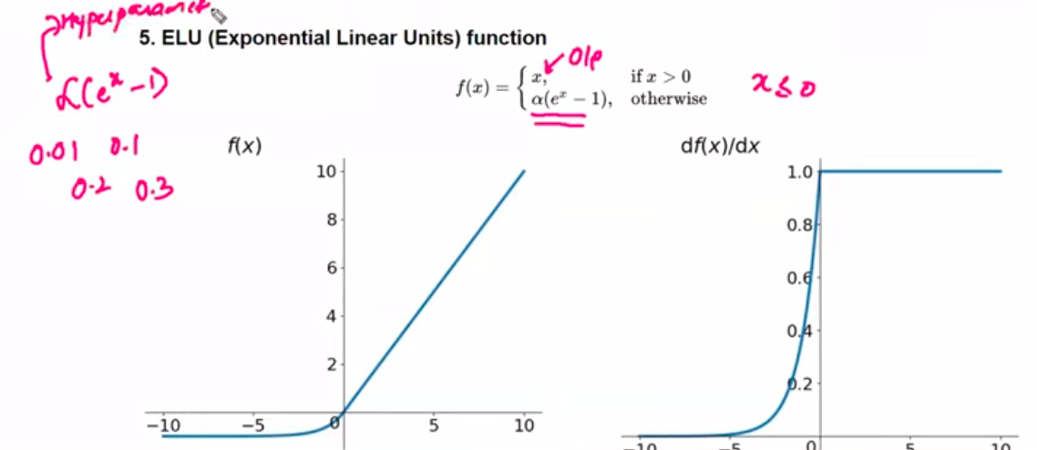

Softmax
Softmax function is often described as a combination of multiple sigmoids. We know that sigmoid returns values between 0 and 1, which can be treated as probabilities of a data point belonging to a particular class. Thus sigmoid is widely used for binary classification problems.
The softmax function can be used for multiclass classification problems. This function returns the probability for a datapoint belonging to each individual class.
While building a network for a multiclass problem, the output layer would have as many neurons as the number of classes in the target. For instance if you have three classes, there would be three neurons in the output layer. Suppose you got the output from the neurons as [0.09003057 0.66524096 0.24472847]
The sum of probabilities is One for Softmax
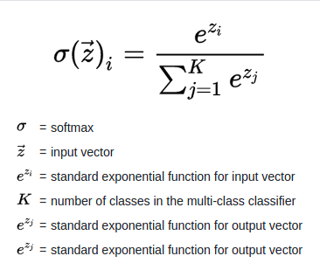

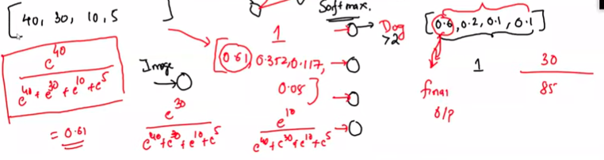
40,30,10,5 is input to softmax AF. Probability of each class in multi-class classification is calculated using above formula.

Swish(A Self-Gated) AF
It is recommended to use only if neural network is greater then 40 layers. LSTM - Long short-term memory is an artificial recurrent neural network architecture used in the field of deep learning. It resolves dead neuron problem since derivative isn’t zero
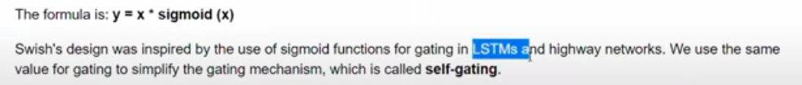
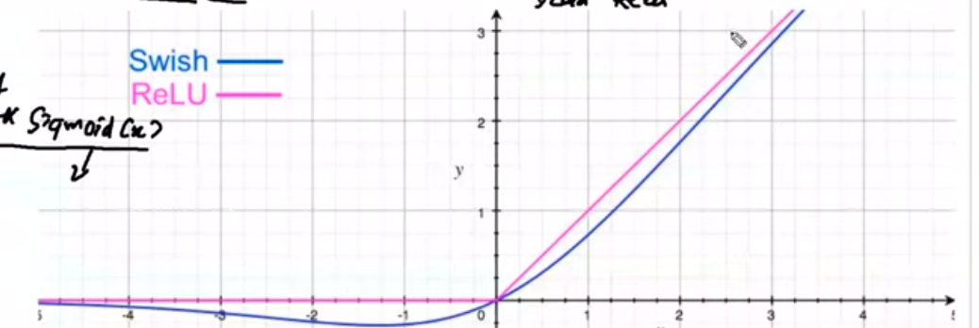

Softplus AF
Violet – ReLU & Green – Softplus. Derivative of Softplus function is Sigmoid function(Pic 2)
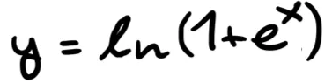
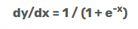

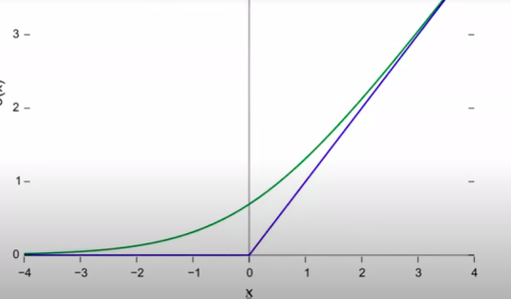
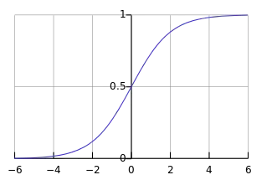
Neural Network Training - Back Propagation
https://medium.com/@14prakash/back-propagation-is-very-simple-who-made-it-complicated-97b794c97e5c
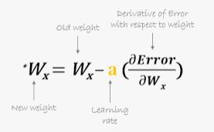
Each feature (or) independent variable is assigned as weight(W1,W2,W3) and passed to neural network layer(here single layer is considered) where AF is applied by using y value.
New weight(W4) is assigned from o/p layer of AF and then another AF is applied at o/p layer. Predicted o/p is compared with actual o/p using loss function for each row and summation of all loss function provides Cost Function(CF) in each epoch( 1 round of training).
Once Cost function is calculated then its back propagated with updated weight to each layer using below formula till independent layer(X1,X2,X3). Optimizer will help to minimize cost function E.g: Gradient descent etc.. Error is nothing but cost function in below formula.

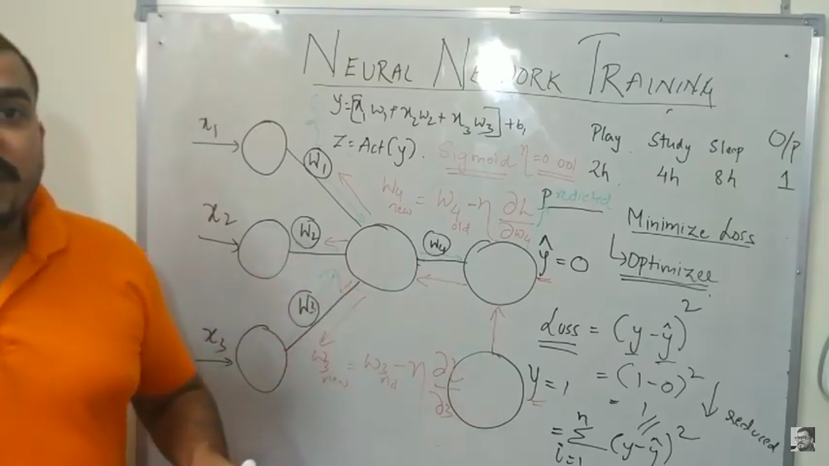
MultiLayer Neutal Network(MNN) training
https://medium.com/@14prakash/back-propagation-is-very-simple-who-made-it-complicated-97b794c97e5c
Derivative (or) slope is steepness of the curve on drawing tangent line at a point. In gradient descent, graph is drawn with weight in x-axis and Loss in y-axis. The purpose of derivate is to find whether slope is positive or negative in a given point.
Gradient Descent: https://www.codeproject.com/Articles/1196024/Machine-Learning-Gradient-Descent. If v take random point of x either in -ve (or) +ve slope then calculating updated weight and its back propagated until v get lower cost function.
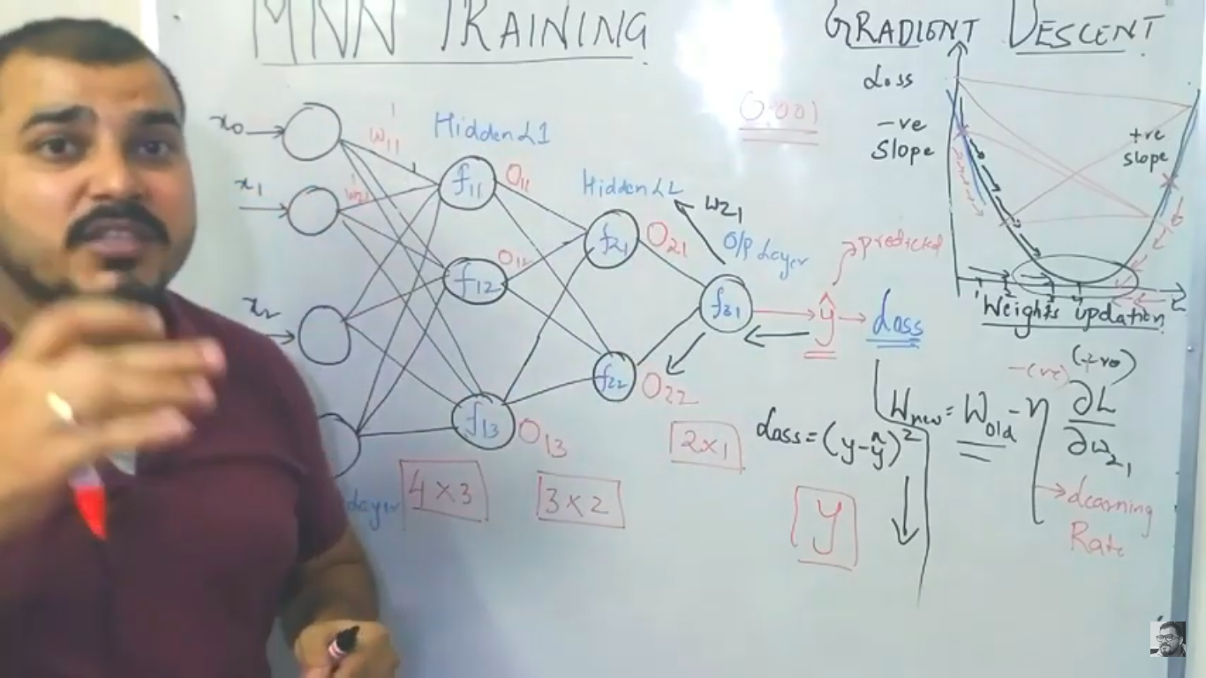

Chain Rule in Backpropogation
https://medium.com/@14prakash/back-propagation-is-very-simple-who-made-it-complicated-97b794c97e5c
Derivative of Loss with W11 can be written as below. Since O31 is impacted by W11, we can expand the derivatives as below.
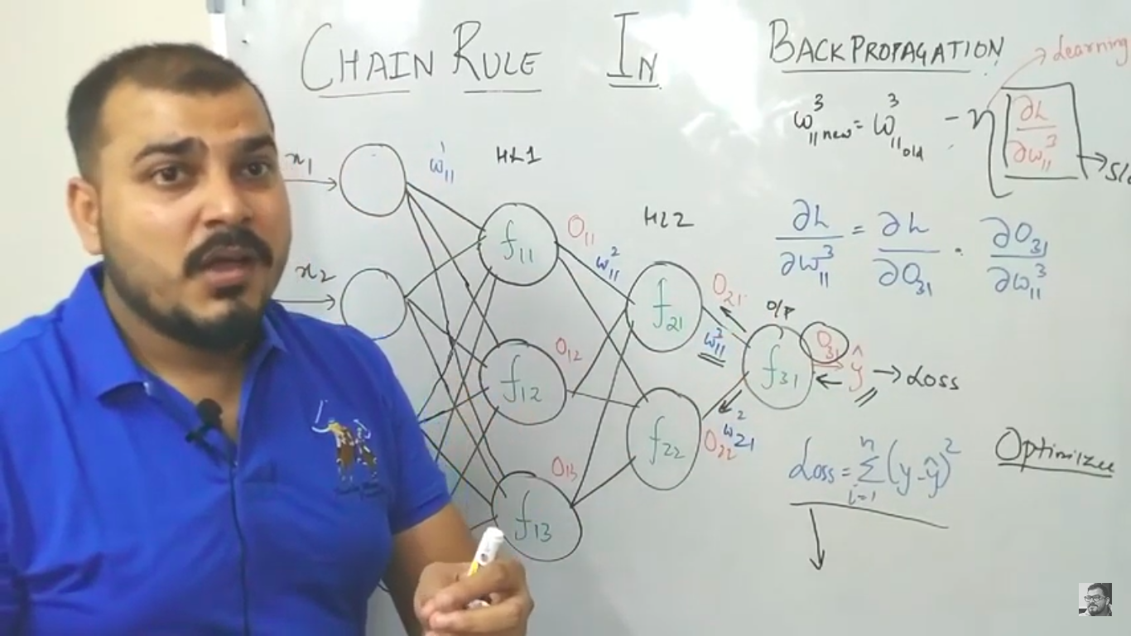
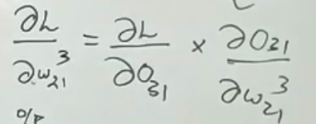
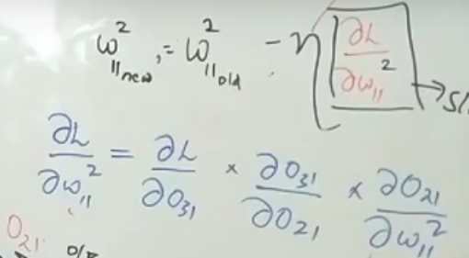
Chain rule is performed for each epoch. A Epoch represent both forward and backward propogation.

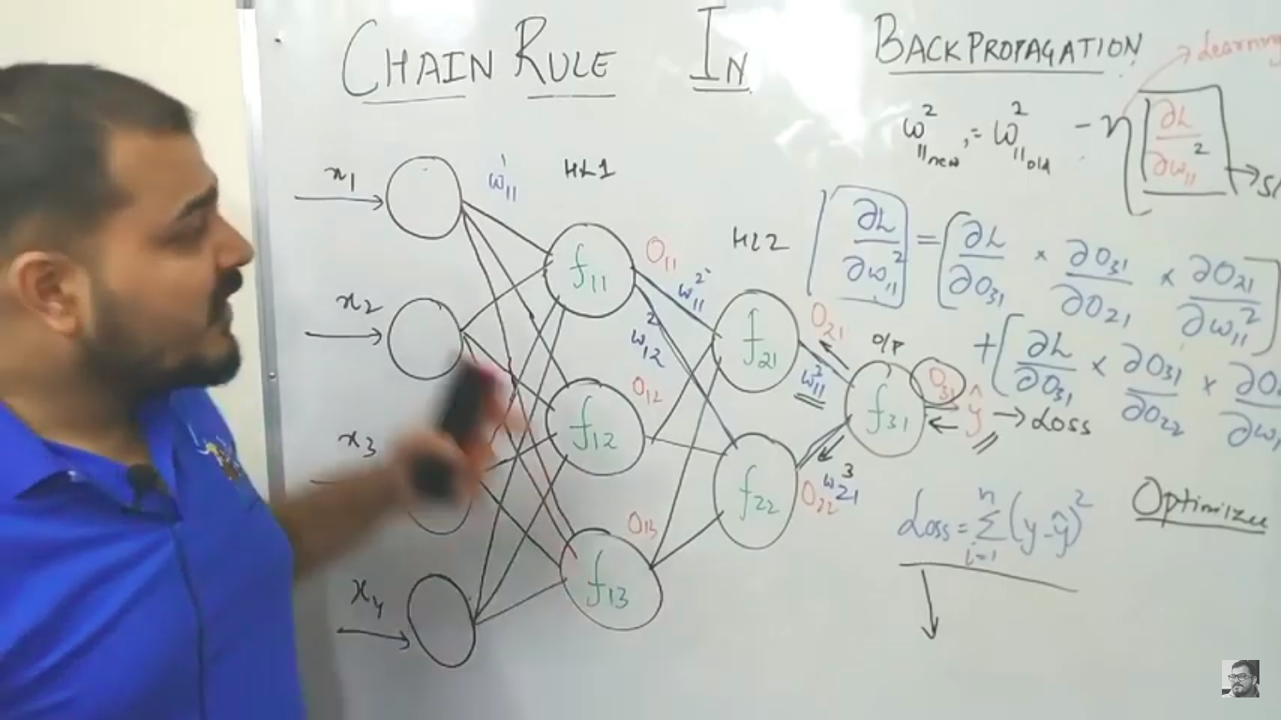
Vanishing Gradient Problem
Derivative of sigmoid function(ranges from 0 to 1) will be between 0 to 0.25. Sigmoid AF is applied in hidden layer.
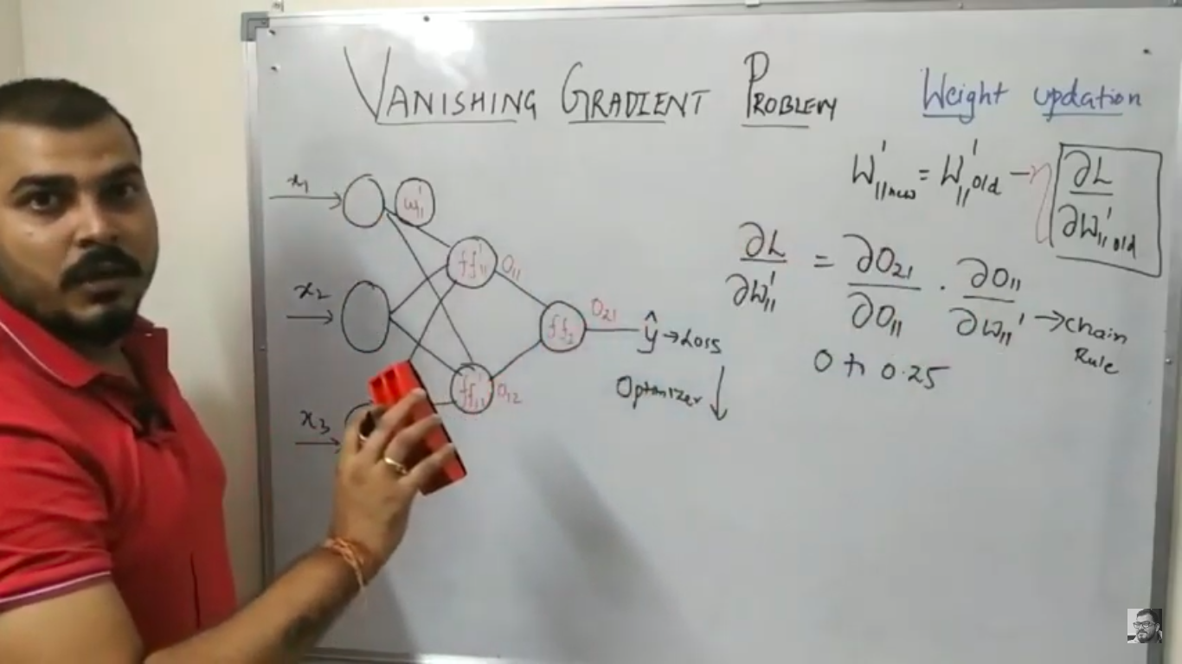
Pic 1: we have taken 0.20 for 1st derivate since derivative of Sigmoid AF ranges from 0 to 0.25. 2nd derivative will be lesser value compared to 1st derivative
Pic 2: Considering older weight as 2.5 and learning rate as 1
Both computation is just for only one layer.
Pic 3: If we have many layers, then derivates of each layer will result in very less value E.g: If we have 4 layers, then derivate of 1st layer on back propagation will be multiplication of all derivatives(chain rule) which will result in very very less value. In this case Wnew will be equal to Wold(Wnew=Wold) since product of learning rate(0.01) and derivative is very less which is negligible. This is called as Vanishing Gradient Problem. This will happen since we are using sigmoid AF. We shouldn’t use sigmoid AF in multiple layers. We will face similar issue in tanh AF as well since its derivative ranges b/w 0 to 1.
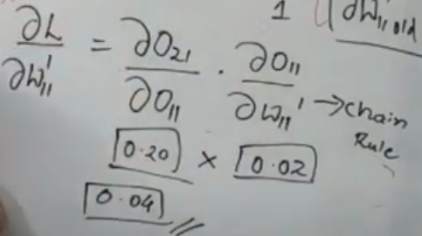
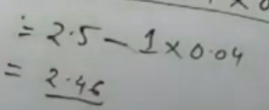

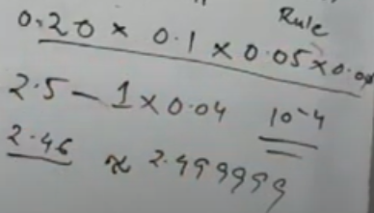

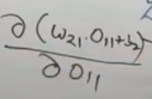
Exploding Gradient Problem
It happens bcoz of weights. Sigmoid AF is applied in FF21 layer.
Derivative(D) of z with O11 is W21 since W21 and b2(bias) is constant

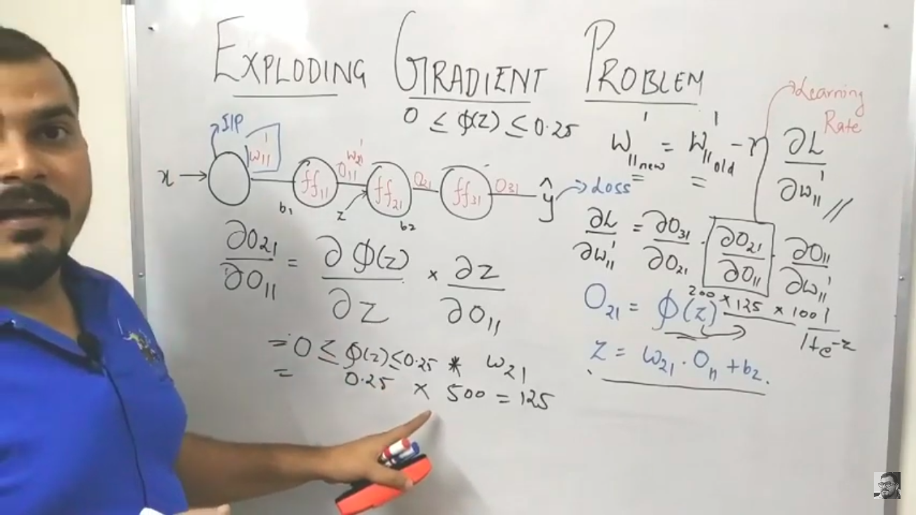
Exploding gradient problem will arise only when the weight is very high. On subtracting older weight with derivatives, it will return very high negative value. On each epoch, weight will be varying a lot which won’t converge to global minima in gradient descent.

Drop out & Regularization
In Multilayer Neural Network(MNN) underfitting won’t happen. Underfitting can happen only if v have single layer. Chances of Overfitting is more in MNN. Dropout ratio(P) ranges from 0 to 1. If P=0.5 then half of the neuron or dependent variable in the layer is activated, others are deactivated. This reduces overfitting problem. This happens only for training data. For test data, all neurons will be connected without dropout. Selecting P value can be done via hyperparameter optimazation. If overfitting is very high, then v need to select higher P value.
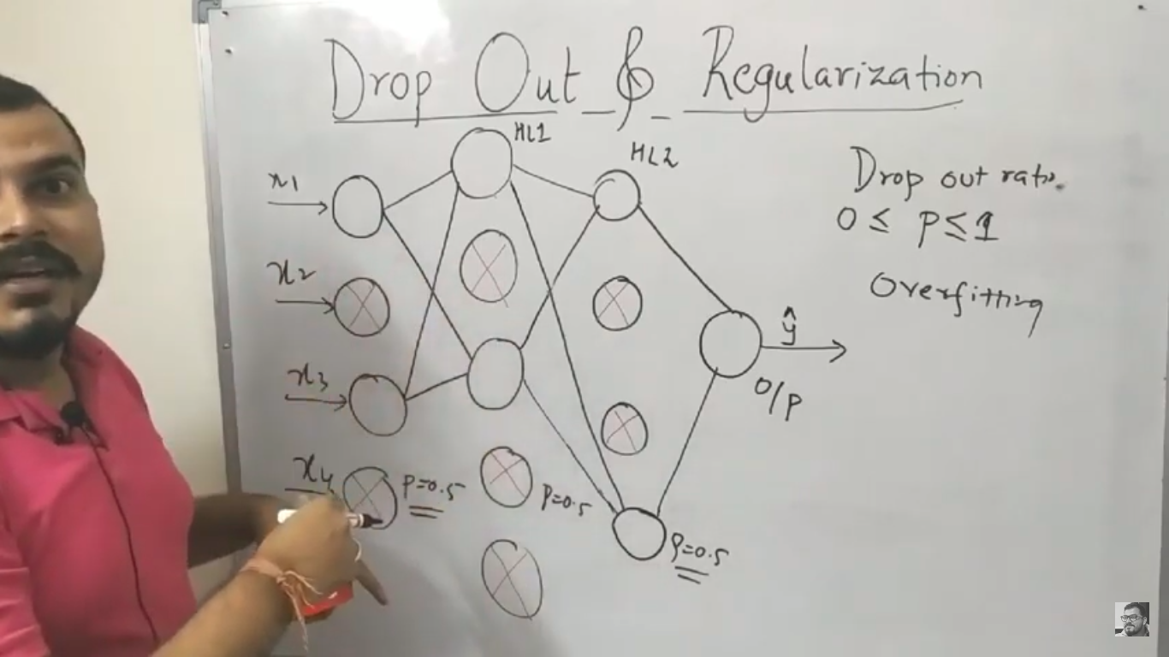

Weight Initialization
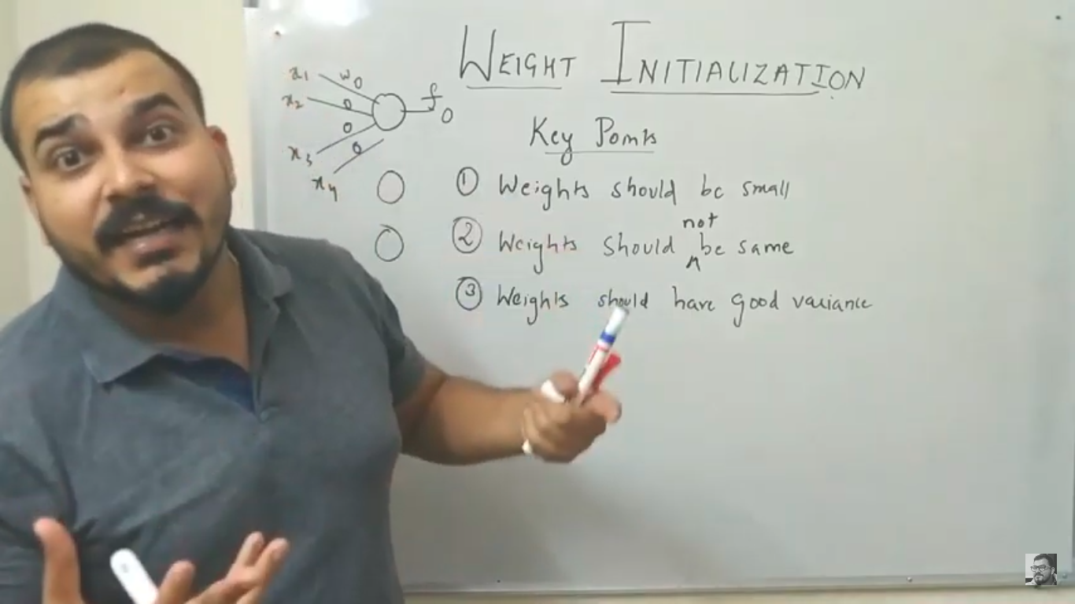
If weights of dependent variable r same, then all neurons behaves same which isn’t optimal

fan_in is no.of input to neuron(3 in below pic). U- Uniform distribution, N-Normal distribution
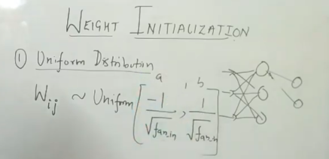
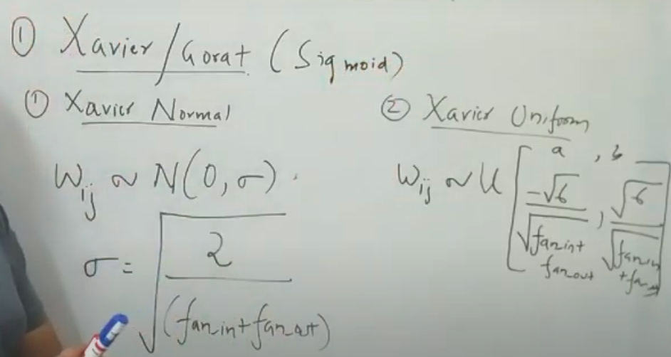
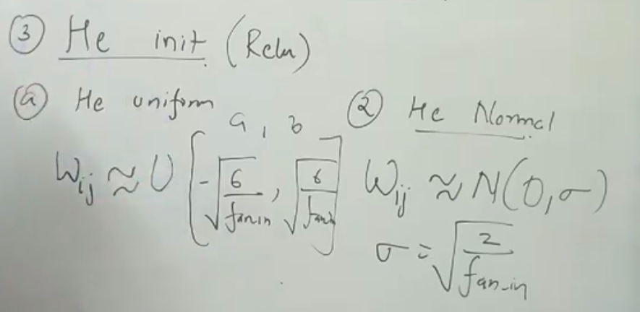

Optimizer
Optimizers are algorithms or methods used to change the attributes of the neural network such as weights and learning rate to reduce the losses. Optimizers are used to solve optimization problems by minimizing the function.

Gradient Descent
A derivative is a continuous description of how a function changes with small changes in one or multiple variables. To clarify, in the parabola example, differentiate “y” with respect to “x”. If we had more features like x1, x2 etc., we take the partial derivative of “y” with respect to each of the features.
****https://datascience.stackexchange.com/questions/30676/role-derivative-of-sigmoid-function-in-neural-networks
****https://www.mygreatlearning.com/blog/gradient-descent
https://www.codeproject.com/Articles/1196024/Machine-Learning-Gradient-Descent
https://www.khanacademy.org/math/multivariable-calculus/applications-of-multivariable-derivatives/optimizing-multivariable-functions/a/what-is-gradient-descent
https://medium.com/@14prakash/back-propagation-is-very-simple-who-made-it-complicated-97b794c97e5c

Stochastic Gradient Descent(SGD)
***https://towardsdatascience.com/stochastic-gradient-descent-clearly-explained-53d239905d31
https://towardsdatascience.com/gradient-descent-algorithm-and-its-variants-10f652806a3
In Gradient Descent(GD), we process all data once and then calculate its cost and back propogate updated weight using gradient descent optimizer. If we have 1000 records(or row) of data then all 1000 data are processed and cost function is computed. If v have huge training set(million) record, then gradient descent will only update weight after processing all dataset then compute cost function and updated weight is backpropogated. Its computationally expensive and utilizes high resource(RAM) memory
In SGD, we compute loss function for each record and update weight in back propogation. If 1000 records r present, v update t weight in back propogation for each record(1000 times). Used in sklearn linear & Logisticsregression.

Mini Batch SGD
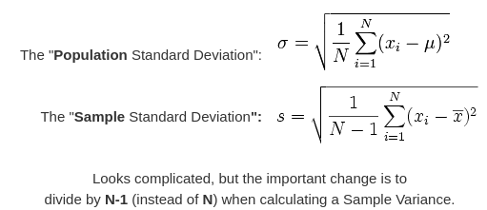
We will run batch of record and update weight in each batch. Its most widely used now. Its performance is good compared to SGD since weight is updated on each batch and utilizes less resource(RAM) memory. Mini Batch SGD moves in zip-zap(Noisy data) unlike GD. Noisy data can be eliminated using SGD with momentum. Derivate of mini batch SGD is approximately equal to GD since mini batch is sample and GD is whole data(population). Calculating mean & SD for sample and population varies.
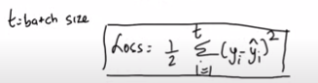
SGD - If training data has 10k record for each epoch it takes 10k iteration. If we have 20 epoch then 20x10k=1 million iteration. It is less resource consuming & computational less than GD but it will slow to reach global minimum. It can be fixed by Mini Batch SGD. 10K-training data & batch size is 1000, then 10000/1000=10. Each epoch will have only 10 iterations. Loss fn for Minibatch SGD
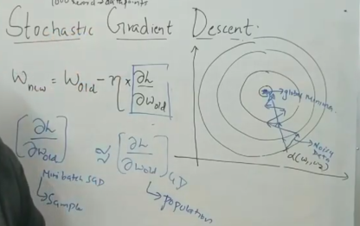
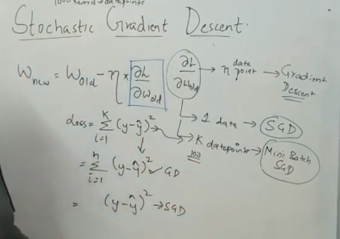

Global vs Local Minima
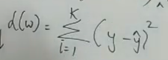
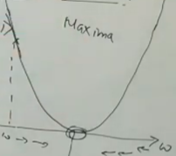
For MSE(Mean Squared error) loss function, curve will be as below. For other cost function, it won’t be same curve.

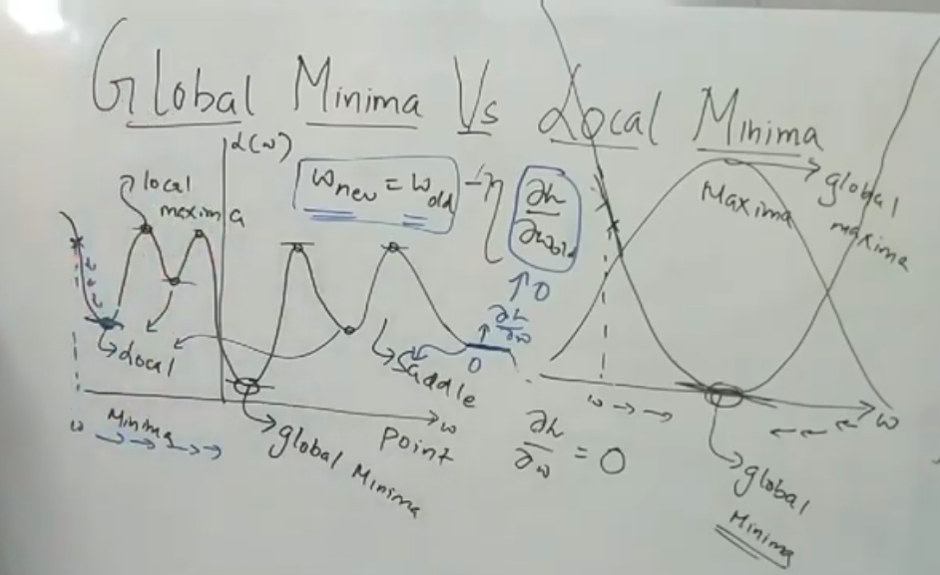
Derivative(Slope) will be 0 at local or global minima & maxima. Incase if v r in 1st local minima, slope will be 0 then Wnew=Wold. Eventhough slope is 0 in local minima, v should be consider it as global minima. Optimizer will help to resolve this issue. Saddle Point is flat line where slope is 0.

Convex Function: It occurs in Linear & Logistics Regression, common in Machine Learning.v ll b having only 1 global minima & 1 global maxima may or may not be present. Area unside curve is considered as 1st area and outside of it is considered as 2nd area. If v r connecting 2 points and lie on single area then its called as convex Function.
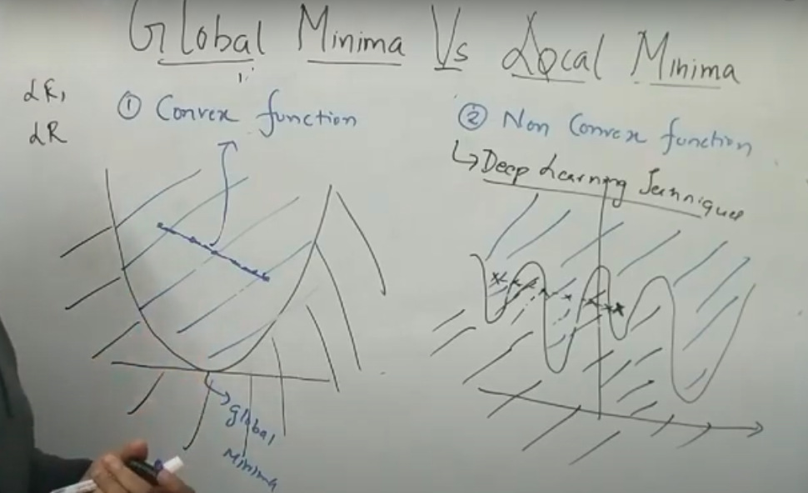
Non-Convex Function: It happens in most of the deep learning techniques since we are dealing with so many weights parameters and neurons. If v r connecting 2 points and lie on different area then its called as Non-convex Function.

SGD with Momentum
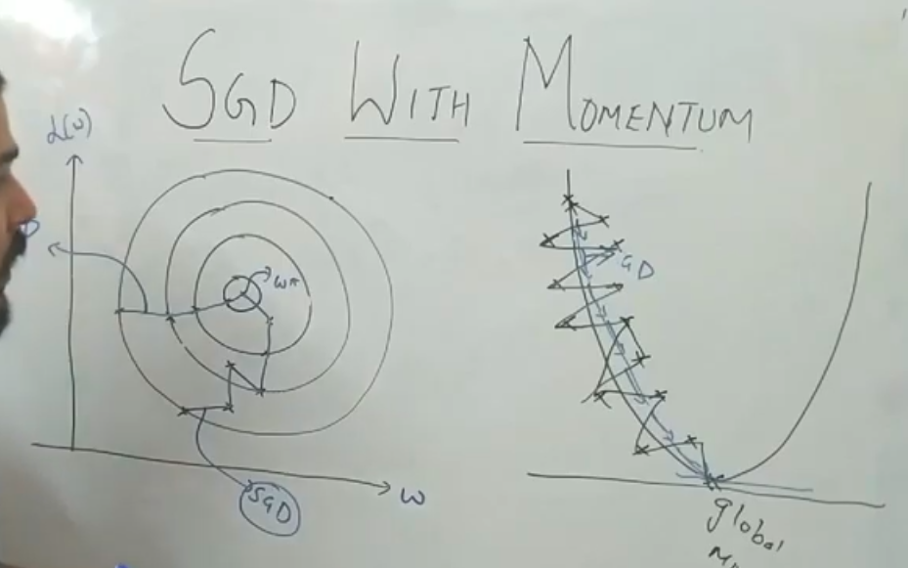
Noisy data(pic 2) will move in zip-zap which won’t converge at global minima, so it needs to eliminated. It can be done using Exponential Weighted Average.
t=time in each iteration, b=data point. Less importance is given to previous points while calculating current data point. It reduces noise(zip-zap) and smoothen the curve. It follows Exponential Wieghted Average.
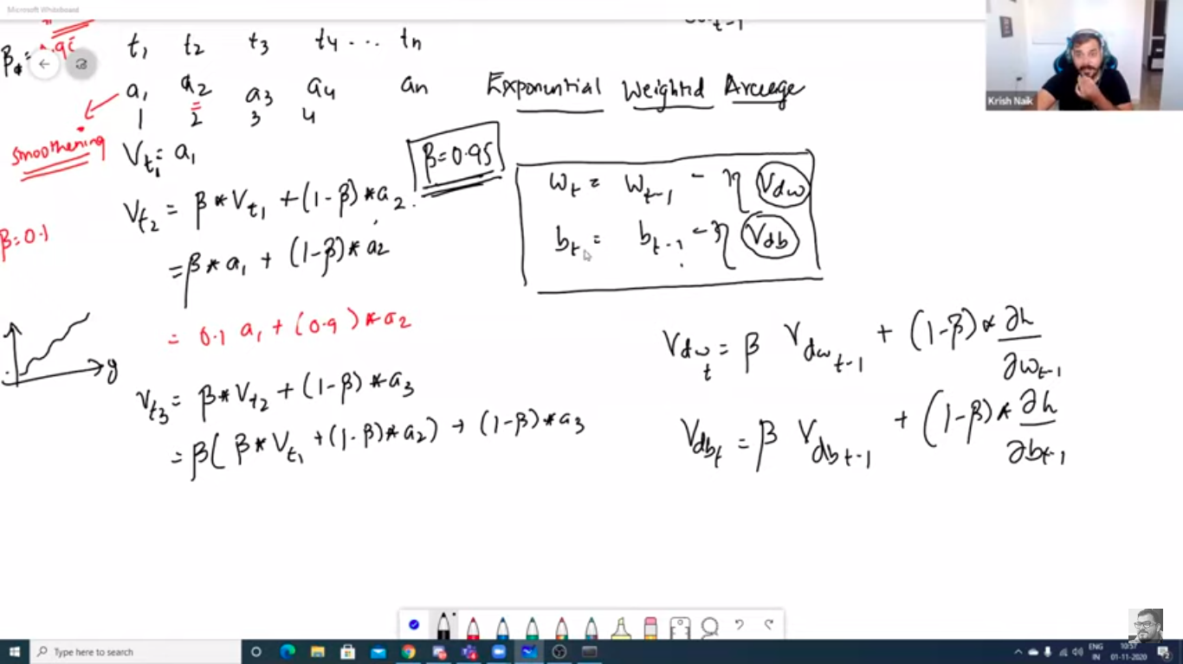
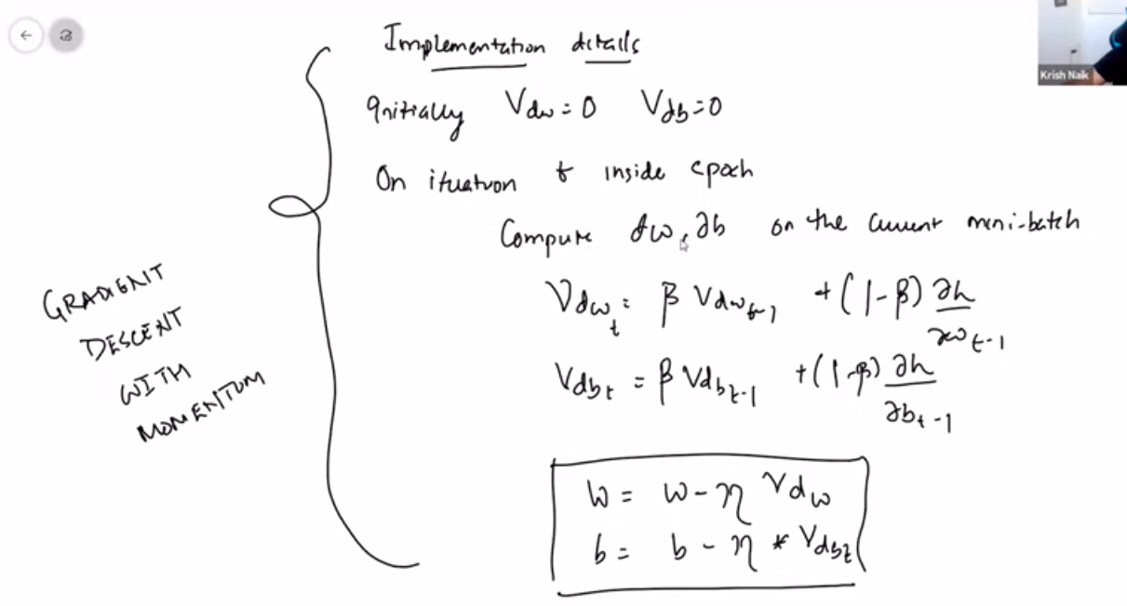

ADAGRAD(Adaptive Gradient Descent)
For GD & SGD, Learning Rate(LR) is fixed at first and all computation happens with the same LR. For ADAGRAD, LR is set dynamically which helps to reach global minima(GM) quickly. Initially it takes higher LR(bigger step) and subsequently followed by smaller LR(smaller step) to reach GM quickly. V use Mini Batch SGD in ADAGRAD.
Alpha is summation of all loss at t where t is time at each iteration. V r adding E(sigma) as small +ve number value & incase if alpha becomes 0, then v ll end up as infinity. Alpha value keeps on increasing on each iteration(t) which is divided by initial learning rate. Any number divided by high number will be very small number on each iteration. In deep MNN where v have several iteration in epoch, alpha value will be too low where Wnew=Wold results in Vanishing Gradient problem. It can be solved using RMSProp.

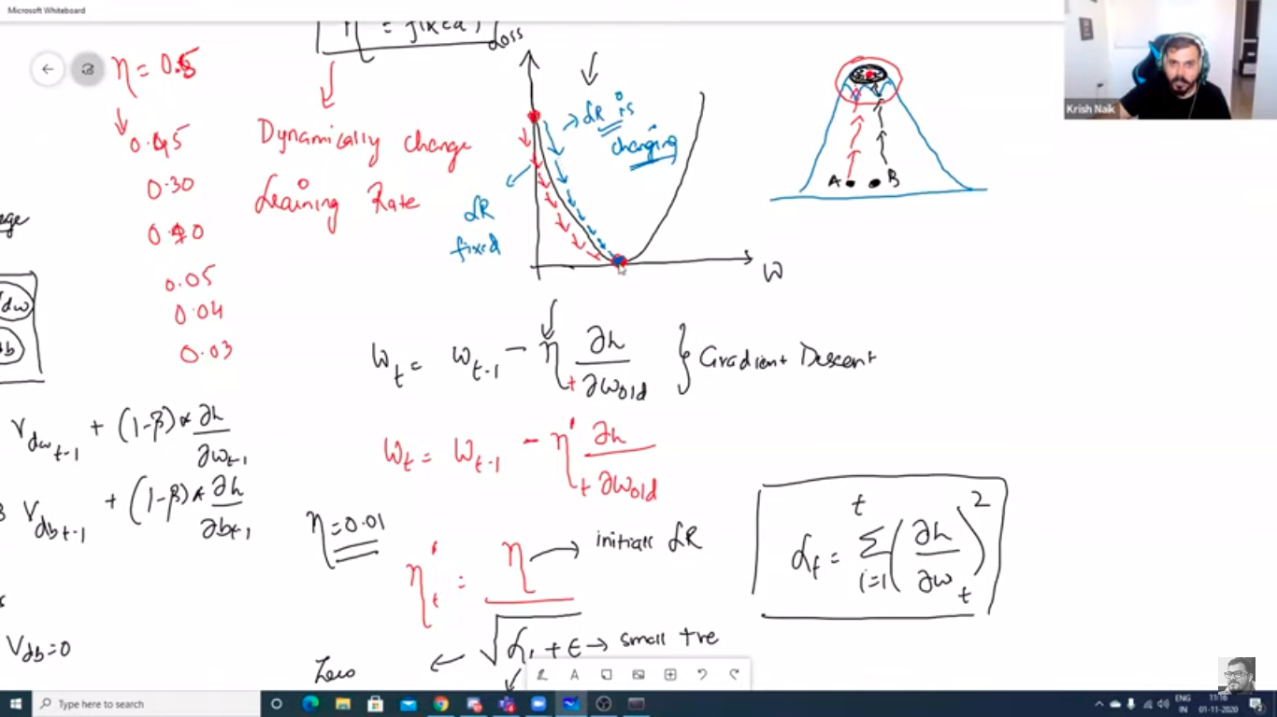
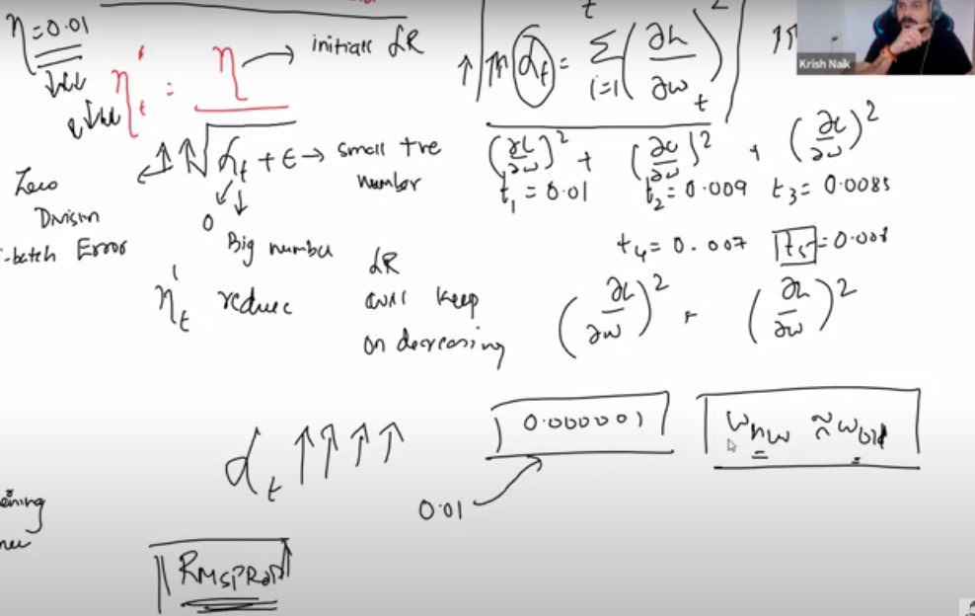
Adadelta & RMSProp(Root Mean Square Propagation)
We follow the same procedure as ADAGRAD. Only difference is how we update LR inorder to overcome least alpha where Wnew=Wold. We use Exponential weight Average for computing LR. Since we have beta in computing LR, we won’t be getting high value in division.
If beta is 0.95, then (1-beta) is 0.05*current weight. Beta ranges from 0 to 1. If beta is selected as 0.95(high value) then higher weight is given to previous datapoint than current. If its 0.05 then higher weight is given to current than previous iteration.
V use Mini Batch SGD in Adadelta & RMSProp.
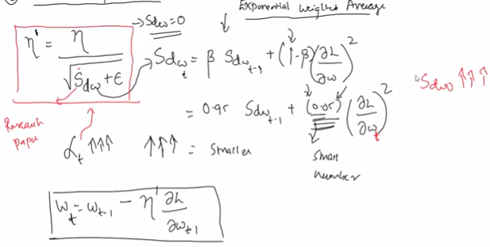
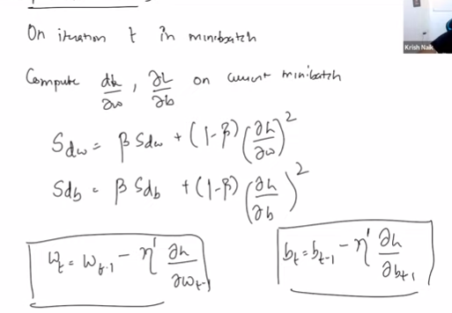

Adam(Adaptive Moment Estimation)
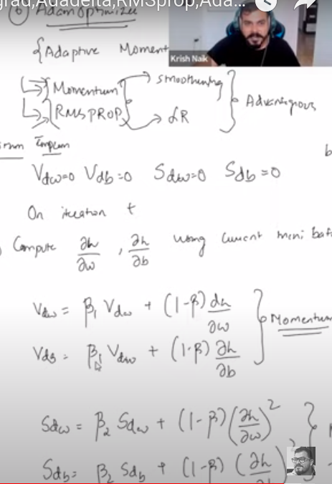
Adam can be looked at as a combination of RMSprop and Stochastic Gradient Descent with momentum. It uses the squared gradients to scale the learning rate like RMSprop and it takes advantage of momentum by using moving average of the gradient instead of gradient itself like SGD with momentum. Let’s take a closer look at how it works.

Convolution Neural Network(CNN)
https://medium.com/@RaghavPrabhu/understanding-of-convolutional-neural-network-cnn-deep-learning-99760835f148
ANN predicts regression and classification problem. If we need to train and predict the images or videos then CNN is best opt for it.
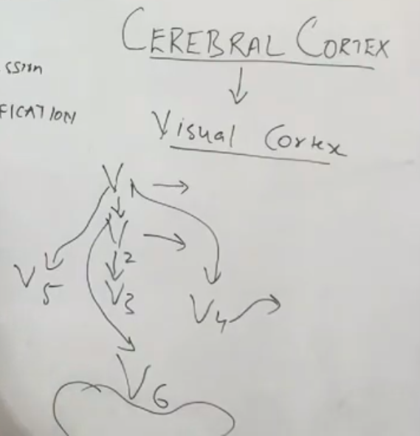
Image information from human eye is passed to Visual cortex(VC) inside cerebral cotex and several VS layers which does some recognization(e.g.: edges of pics, identifying cat and dog in single image etc) which finally recognize the pic.

Convolution
Image consists of several pixels. Grey scale is black & white image which ranges from 0 to 255 pixels. For colored image(pic 2), 3 layers are formed(RGB). If pixel is 6x6, for grey scale --> 6x6. For RGB, its 6x6x3(since we have 3 layers – RGB). Each layer will have 0 to 255 pixels. Pixel can be normized between 0 to 255 using MinMaxScaler.
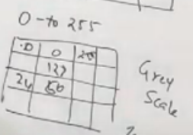
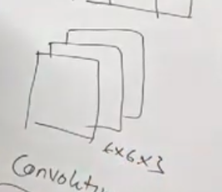

3x3 pixel is filter. Below filter will deduct vertical edges. 2nd pic does horizontal edge detector. Similarly we have different filter to deduct the image. We just need to mention fiter size & no. Of filters to use, keras will apply different type of filters while training the data. Each 3x3 image pixel is multipled with filter then its sum is placed in o/p filter. Once 1st 3x3 is over, it moves 1 step further. Below calculation is for 2nd 3x3 matrix. i/p image, feature detector(filter) & Feature Map(o/p).
Refer TensorFlow-Udemy.odt in /home/vinoth/Learning/Python
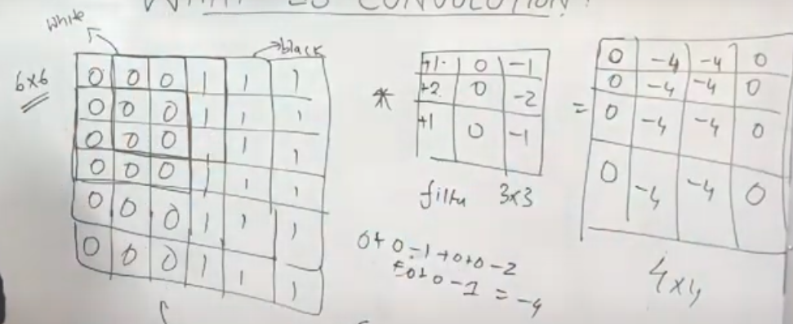
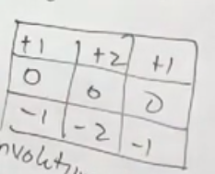
Applying min-max scaler to 0/p matrix which we got. Since -4
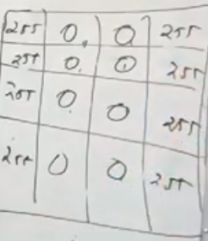
is min and 0 is max value, min-max scaler convert it to 0 for min value and 255(maximum pixel in a image) for 0 in o/p
0 is white side & 255 is the dark side(Black).
i/p=6x6, filter=3x3, o/p=4x4
o/p = n-f+1 = 6-3+1=4

Padding
When we apply 3x3 filtering to 6x6 image then o/p is 4x4. We are losing the pixels in the image. Inorder to get same pixel in o/p as i/p pixels, we need to apply padding. We add a new column & row to i/p pixel to get same o/p pixels as i/p pixels. Padded column will have same input as adjacent pixel. n-Actual size of i/p pixel, p-padding, f-filtering
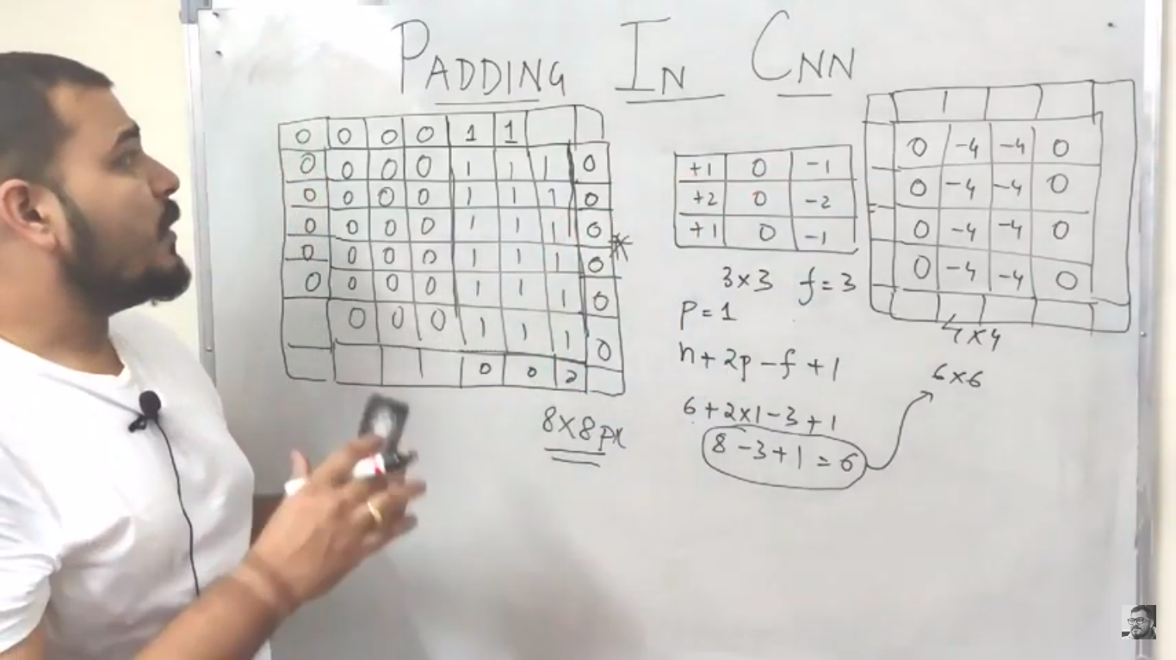

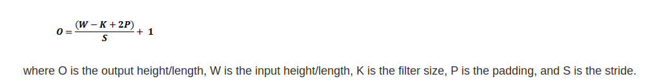

Operations of CNN
Image pixel is processed with several filters which detects image by horizontal, veritical edges, detecting face, eyes etc then we obtain o/p layer. Each pixel in o/p layer is then applied with RELU activation function.
Filtering is applied one after the other. If filter has layers(V1,V2,V3,V4 etc). First filtering is applied to V1 then filtered image from V1 is then passed to V2. This continues till last layers to deduct the image.

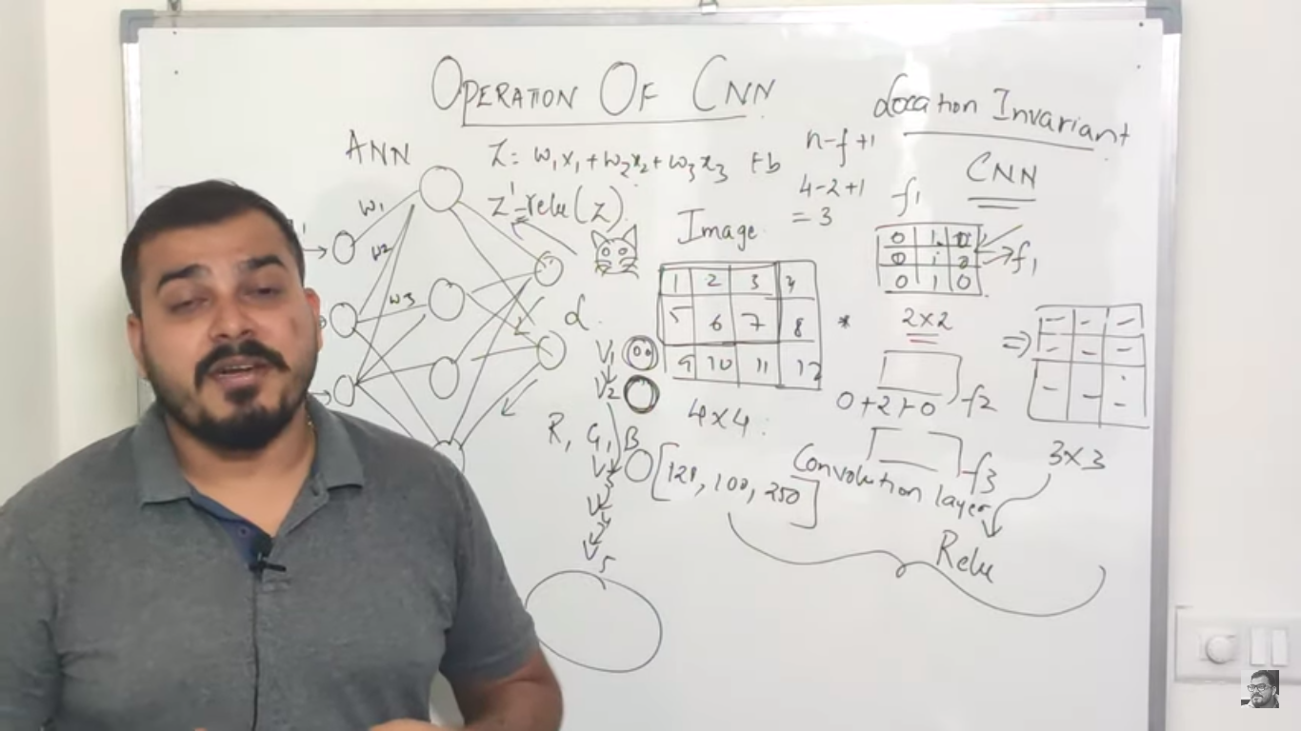
Max Pooling
Location Invariant
Feature Map is the result of previous convolution step. Selecting 2x2(which is commonly used) in this example. We may have nxt selection. It picks maximum number in 2x2. It reduces noise to prevent overfitting. Max pooling takes only high important details in feature map by picking highest value. There is concept called sum pooling, mean pooling & sub-pooling. In below selection.
We have horizontally stacked convolution(filtering) and then pooling layer. Convolution and Pooling layer pixels will be updated in back propogation.
http://scs.ryerson.ca/~aharley/vis/conv/flat.html – Which provides details of all layer(Convolution, Pooling etc)
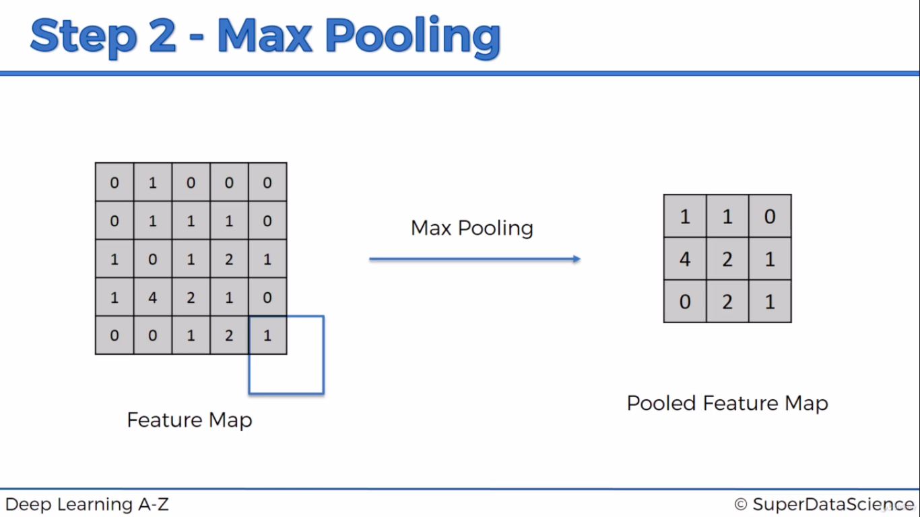
Stride is the number of pixels shifts over the input matrix. When the stride is 1 then we move the filters to 1 pixel at a time. When the stride is 2 then we move the filters to 2 pixels at a time and so on.
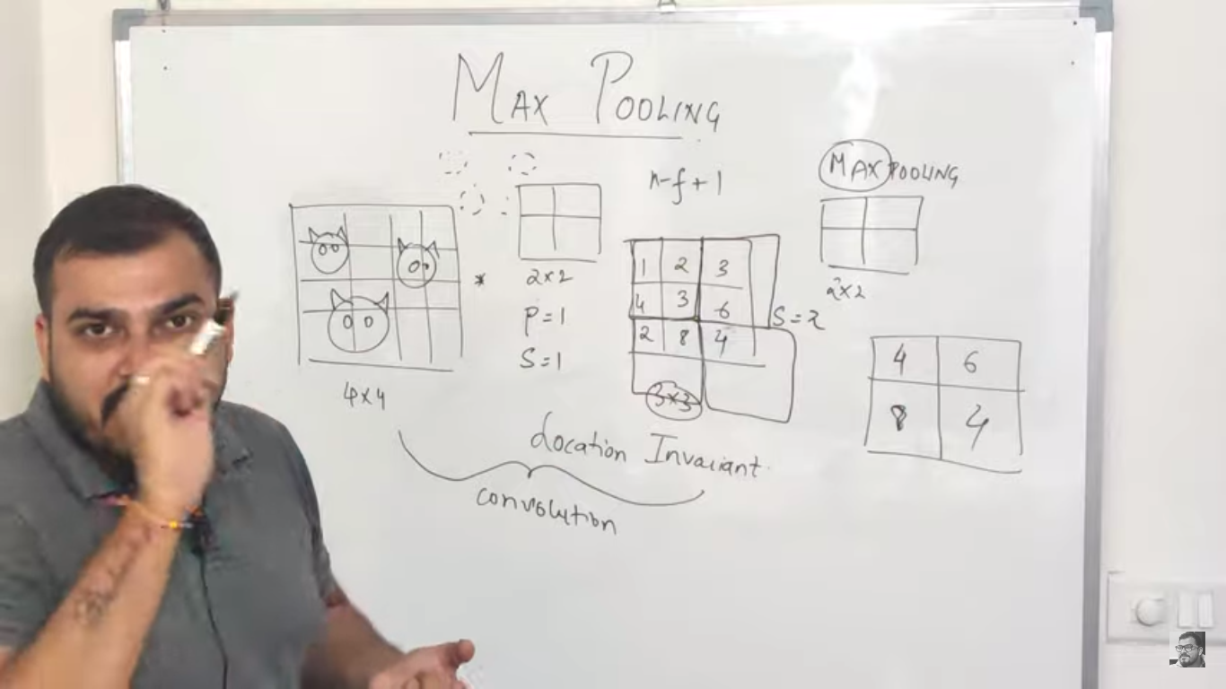

Types
Min Pooling – takes minimum value in pixel, Sum Pooling=6, Mean Pooling=6/4=1.5, sub pooling=

Data augmentation
Once the image is inputed, CNN goes fliping, horizontal & Vertical fliping etc and then it applies filtering to the altered image. It is called Location Invariant.

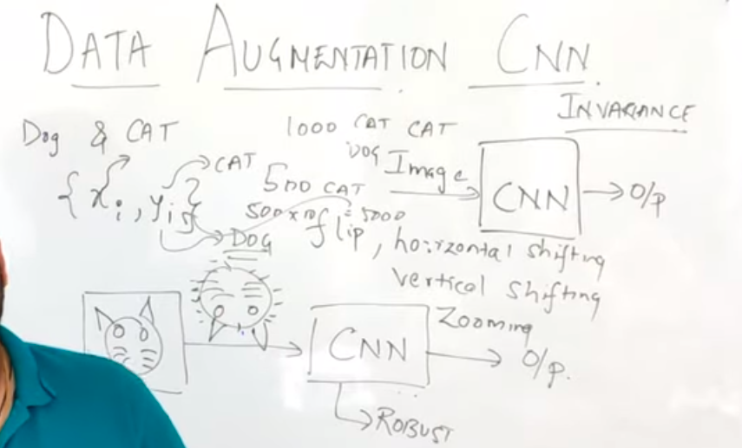
Transfer Learning
https://en.wikipedia.org/wiki/ImageNet
https://keras.io/api/applications/
https://towardsdatascience.com/keras-transfer-learning-for-beginners-6c9b8b7143e
https://machinelearningmastery.com/how-to-use-transfer-learning-when-developing-convolutional-neural-network-models/
*** https://github.com/BVLC/caffe/wiki/Model-Zoo
The ImageNet project is a large visual database designed for use in visual object recognition software research. More than 14 million[1][2] images have been hand-annotated by the project to indicate what objects are pictured and in at least one million of the images, bounding boxes are also provided.[3] ImageNet contains more than 20,000 categories[2] with a typical category, such as "balloon" or "strawberry", consisting of several hundred images.[4] The database of annotations of third-party image URLs is freely available directly from ImageNet, though the actual images are not owned by ImageNet.[5] Since 2010, the ImageNet project runs an annual software contest, the ImageNet Large Scale Visual Recognition Challenge (ILSVRC), where software programs compete to correctly classify and detect objects and scenes. The challenge uses a "trimmed" list of one thousand non-overlapping classes.[6]

VGG16, VGG19 will predict 1000 labels(images) in final(o/p) layer.

R-CNN, Fast R-CNN, Faster R-CNN, YOLO
R-CNN- Region Based CNN, YOLO – You Only Look Once
https://towardsdatascience.com/r-cnn-fast-r-cnn-faster-r-cnn-yolo-object-detection-algorithms-36d53571365e

Recurrent Neural Network
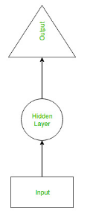
https://www.geeksforgeeks.org/introduction-to-recurrent-neural-network/
Recurrent Neural Network(RNN) are a type of Neural Network where the output from previous step are fed as input to the current step. In traditional neural networks, all the inputs and outputs are independent of each other, but in cases like when it is required to predict the next word of a sentence, the previous words are required and hence there is a need to remember the previous words. Thus RNN came into existence, which solved this issue with the help of a Hidden Layer. The main and most important feature of RNN is Hidden state, which remembers some information about a sequence.RNN have a “memory” which remembers all information about what has been calculated. Its used in NLP, Bag of Words, TF-IDF, WORD2VEC.

Architecture
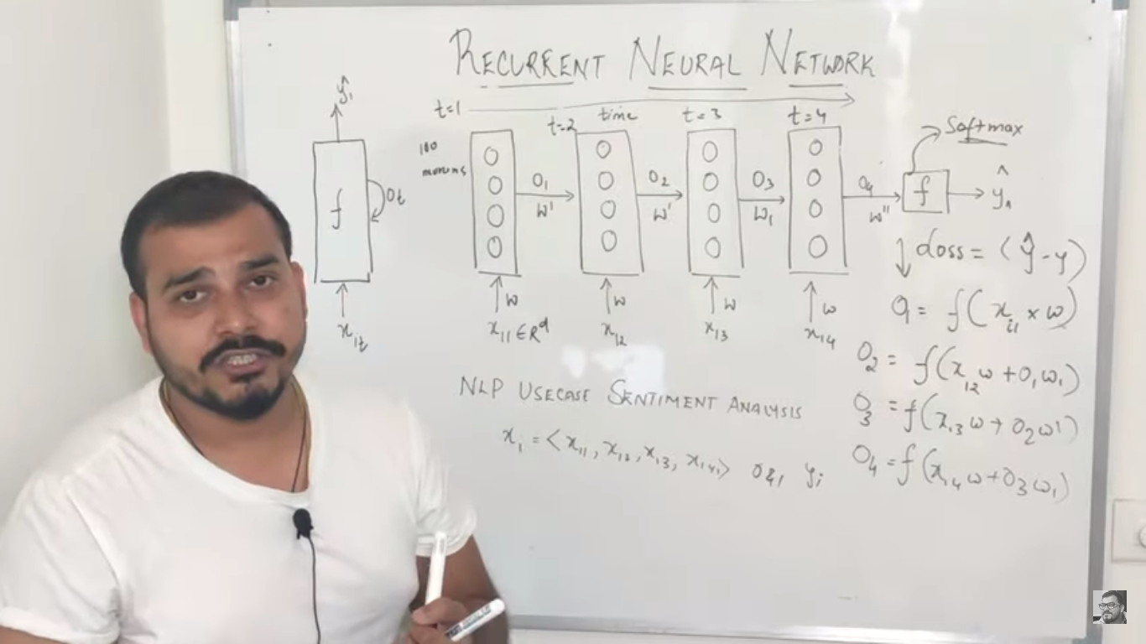
X is i/p features(any number of i/p features), f is hidden layers with any number of neurons. Above pic explains forward propogations. o/p of hidden layer is passed to hidden layers again. Hidden layers is expanded in right side.
Input X is given to hidden layer(f) where some activation function is applied and o/p is then generated. o/p is given as input to next time(t=2). Same hidden layer is applied again and again base on time series. In above pic, same hidden layer is applied based on time(t=1,2,3,4).

Back-propogation
Back propogation is explained in Chain Rule in Backpropogation. Derivative at time t=4 is explained below
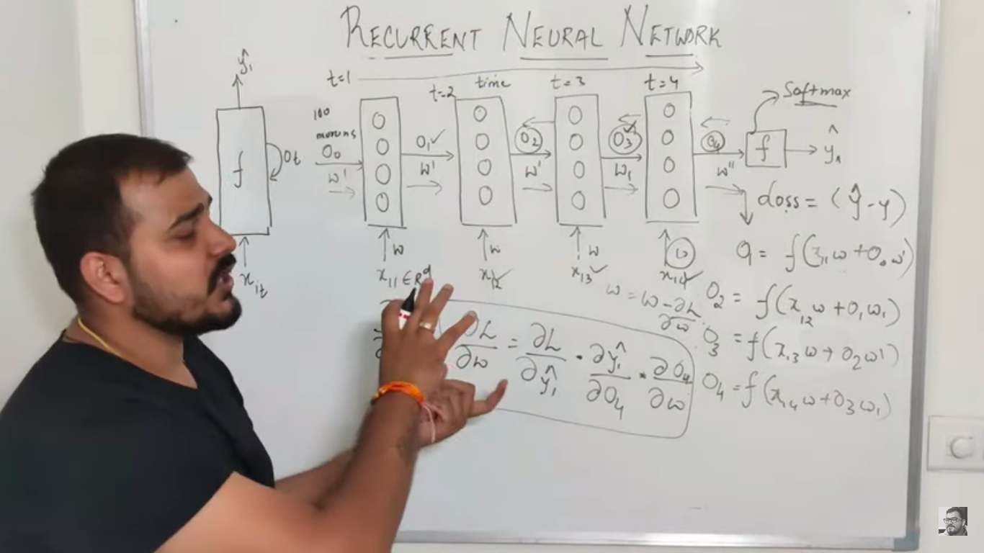

Drawbacks
If we apply Sigmoid Activation Function(AF) where derivative ranges 0 to 0.25 will result in Vanishing gradient problem(Vanishing Gradient Problem). If v apply ReLU AF, it results in Exploding Gradient Problem. This will happens based on successive time period(If we do back propagation at time t=4 & weight at t=1 will result in vanishing gradient problem).
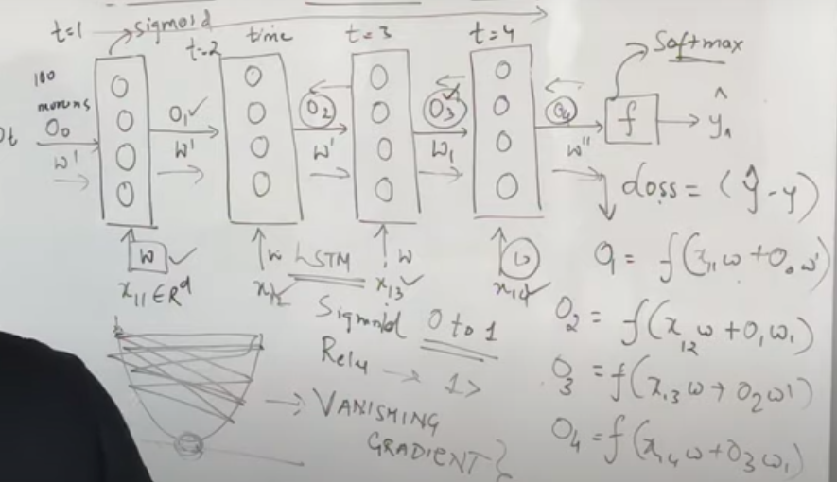

LSTM(Long Short Term Memory)
https://colah.github.io/posts/2015-08-Understanding-LSTMs/
*****https://medium.com/analytics-vidhya/rnn-vs-gru-vs-lstm-863b0b7b1573
Memory Cell: It remembers and forget the context of i/p.

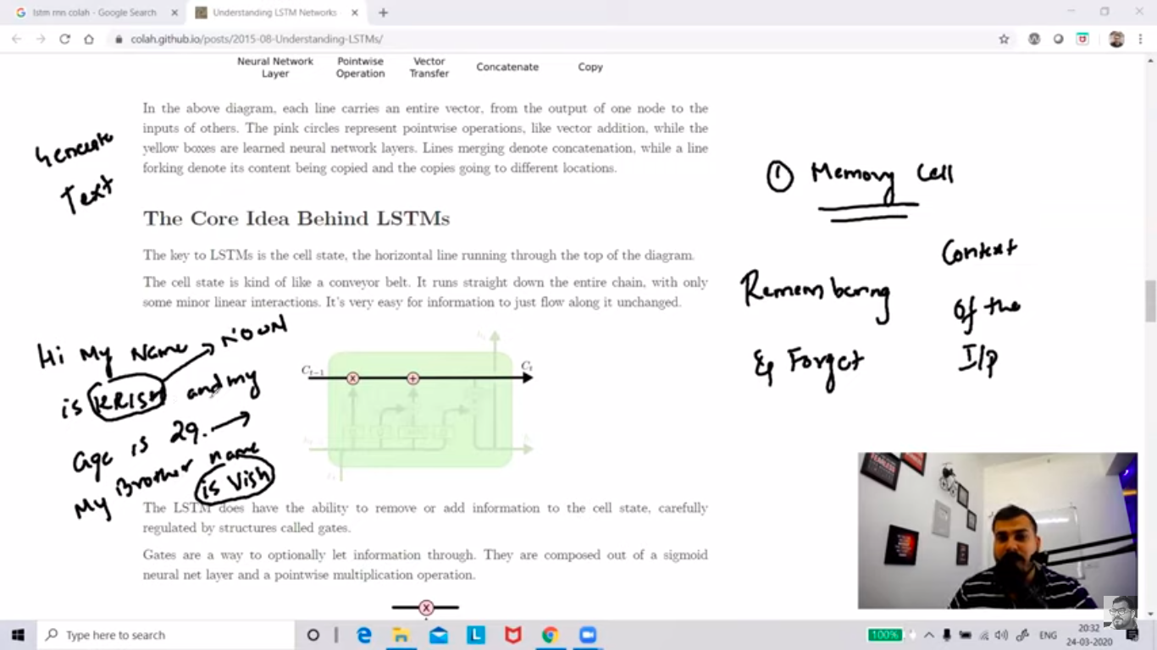
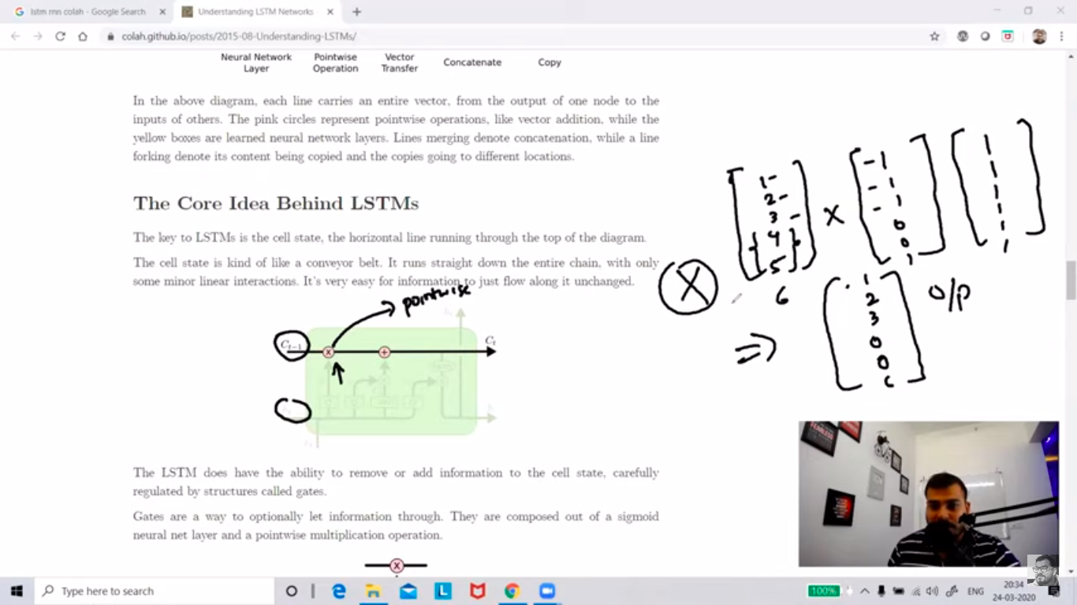
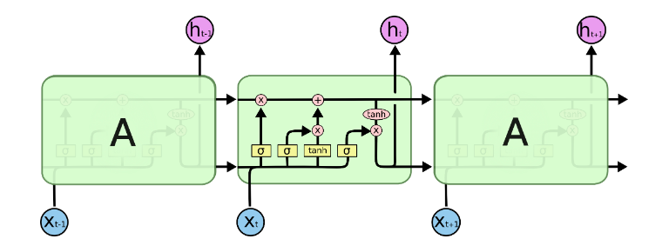
Step 1: Gates are a way to optionally let information through. A value of zero means “let nothing through,” while a value of one means “let everything through!”
First is the vector of previous context of the word, 2nd i/p to pointwise. Product of both is my o/p. Product at 4 & 5 position is 0, so forgetting this information.
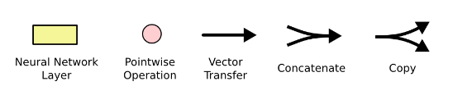
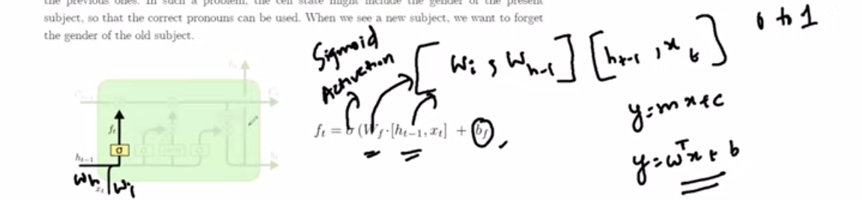
We are concatenating previous weight with current weight & applying sigmoid function on it. This formula is similar to y=mx+b.

If there is change in context(2 different words or sentence), sigmoid function returns 1. E.g.: context of King, Queen are similar(Word2Vec returns 1) but king & poor are in different context(Word2Vec returns 0).
Word2Vec
Word2vec is a two-layer neural net that processes text by “vectorizing” words. Its input is a text corpus and its output is a set of vectors: feature vectors that represent words in that corpus. While Word2vec is not a deep neural network, it turns text into a numerical form that deep neural networks can understand.
By applying sigmoid function in above pic, will return 0 or 1. If it returns 0 then it will forget it.
Step 2: Adding information
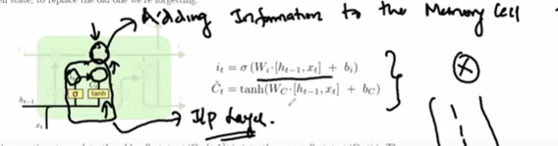
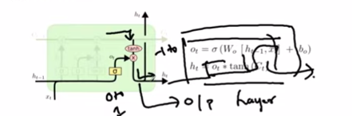
i/p of sigmoid and tanh is passed to x(pointwise multiplication) and o/p is given to pointwise addition operation. Which are all the meaningful context will be the o/p after applying sigmoid(0 to 1) and tanh(-1 to +1) operation.
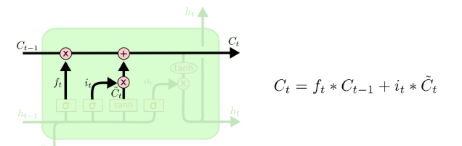

If there is no change in context, we get 1 in 1st pointwise product(X) and then its added 2nd pointwise addition(+). Unless there is no change in the context, value will be always 1.
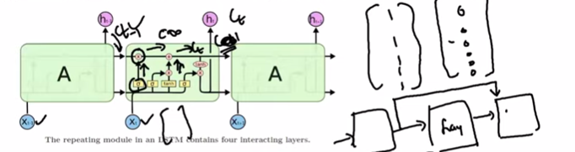
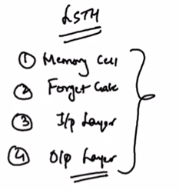

Word Embedding (Feature Representation)
https://machinelearningmastery.com/use-word-embedding-layers-deep-learning-keras/
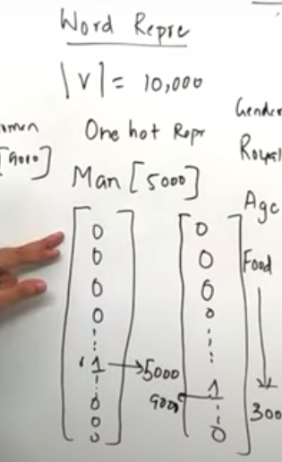
Word Representation
|v| dictionary containing 10000 words. If v represent word “Man” which is present at 5000 index in dictionary(10000 dimension), it will b set as 1 in 5000 index. Its called as One Hot Representation. Its very hard to find the similar words in this vector since the word is only available in specific index with value as 1 in the vector. Its sparse Vector(0 or 1) & size is very big. It has several shortfalls.

Feature Representation
It detemines the i/p word against features(Gender, Royal ..etc) & calculate the chances. Gender is more opt for Boy(-1) & Girl(1) etc. It maintains Low dimension & Dense matrix. We will apply cosine similarity to find analogy of words.
In word representation, we had 1000 vector but here v have only 300 Dimensions. When we subtract Boy & Girl then only 1 matching value will be big number, other will be close to 0. It determines analogy(similarity) between the words. Analogy for king is queen. If we convert 300 dimension data to 2D, similar word will be near(pic 2).
/home/vinoth/Learning/Python/Workouts/ML-Udemy-Git/Section 7:Natural Language Processing(NLP)/KERAS_WORD_EMBEDDING.ipynb
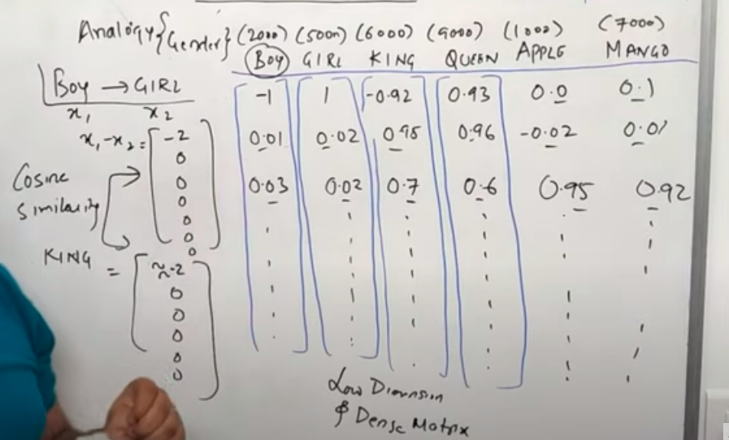
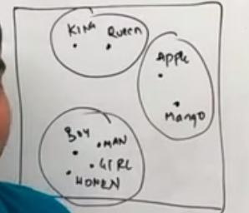

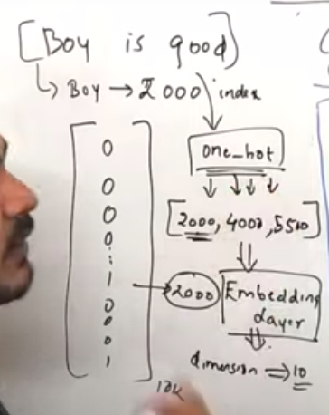
If sentence is “Boy is Good”, then index of each word is selected. If v have 10k vocabulary, Boy is at 2000 index etc. one_hot will detect index of the word and Embeding layer will change its dimension in keras.

Bidirectional LSTM RNN
New RNN hidden layer will be available in Bidirectional RNN. This helps in identifying the next result from the previous one in backend direction. If Y13 needs to predicted then i/p from X14 is available in last hidden layer is given as i/p to previous RNN hidden layere which is then combined with X13 to predict Y13. It works well in NLP since we are recognising previous and next result. Its performance is slow compared to simple RNN or LSTM.
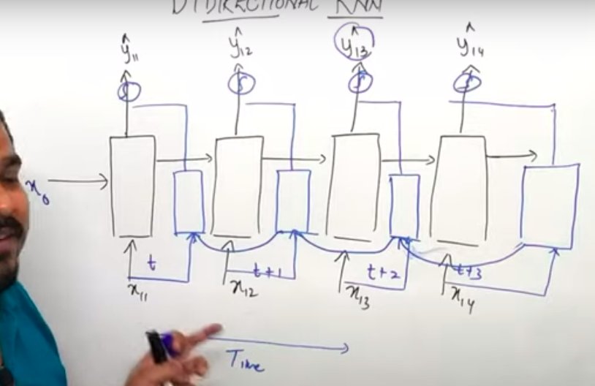

Sequence to Sequence with Neural Network
https://www.analyticsvidhya.com/blog/2020/08/a-simple-introduction-to-sequence-to-sequence-models/
https://github.com/farizrahman4u/seq2seq
****https://blog.keras.io/a-ten-minute-introduction-to-sequence-to-sequence-learning-in-keras.html
Encoder – Encoding the sequence. Decoder – decodes sequence to desired result.
E.g: Language translator which converts english to french. Text to image. i/p to encoder is english words, context vector(W) is passed to decoder which converts it to french words.
o/p won’t be available in encoders at every timestamp but o/p will be available in last timestamp(tn+1) which is EOS(End Of the Stream/Sentence). Every text is passed in the form of vector(W – o/p(Context Vector)). Vector can be formed using Embedded Layer, one hot encoding or word2vec. Vector is then passed to decoder. Consider A,B&C as english character, X,Y&Z is french character in training set. We will get context vector for A,B&C, W(vector) is passed to get X as o/p then its o/p is passed as i/p to next layer.
X=<x1,x2,x3> --> i/p, y=<y1,y2,y3> --> o/p of training data.y^ is o/p of test data. y^ is the combination of (y1^ ,...,yt^). Probability of y^ depending on sequence of input.
Finally, the loss is calculated on the predicted outputs from each time step and the errors are backpropagated through time in order to update the parameters of the network. Training the network over a longer period with a sufficiently large amount of data results in pretty good predictions.

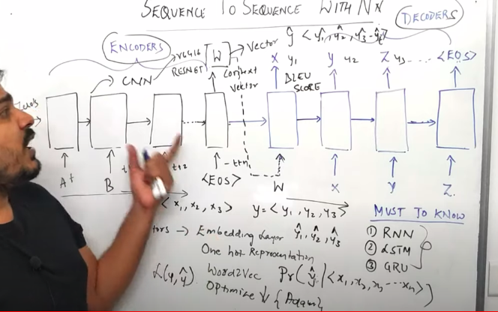

Encoder Decoder
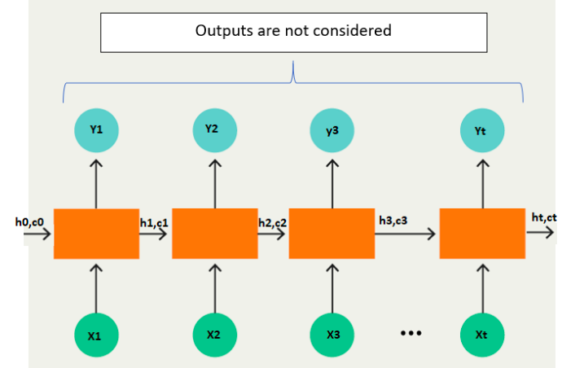
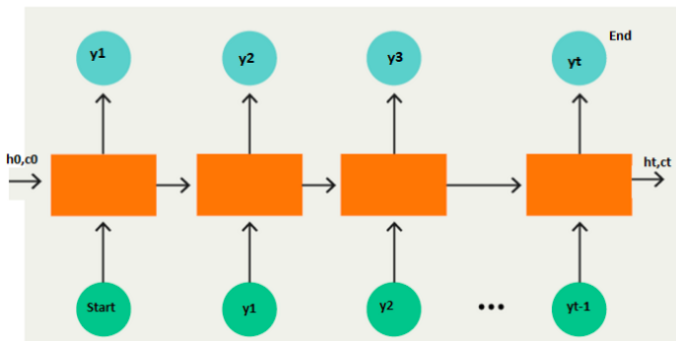

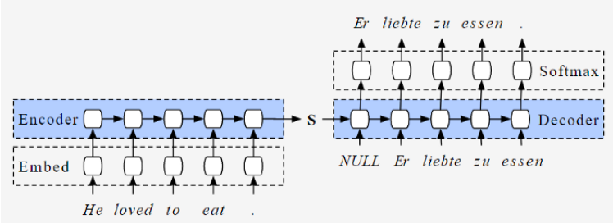

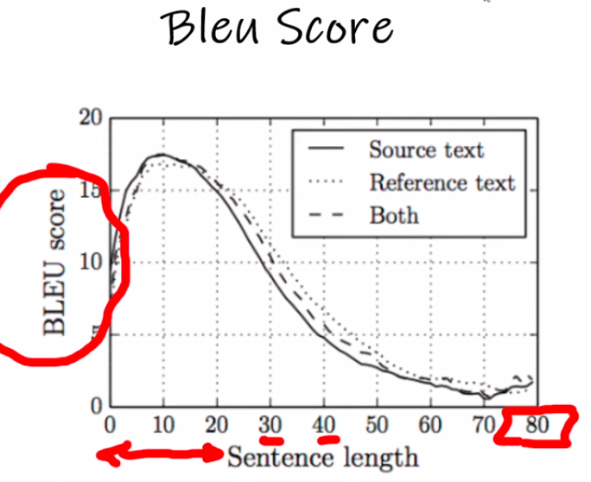
Problem with Encoder & Decoder
If we have bigger sentences, it isn’t able to translate it. If we have sentence length(0-20), BLEU score is high but it decreases with high sentence length. If a translator needs to convert bigger sentences from English to French, its hard to convert essense of each word. Performance of the encoder-decoder network degrades rapidly as the length of the input sentence increases leading to Vanshing gradient problem
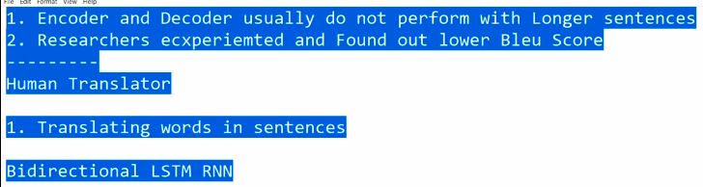

Attention Model
https://www.analyticsvidhya.com/blog/2019/11/comprehensive-guide-attention-mechanism-deep-learning/
*** http://jalammar.github.io/illustrated-transformer/
Research Paper: https://papers.nips.cc/paper/2017/file/3f5ee243547dee91fbd053c1c4a845aa-Paper.pdf
If we have very long sentence then its hard to translate using encoder and decoder. Attention model will select window size(e.g: 5 words to select to translate from English to French).
1: In the research paper, its mentioned that 5(hyperparameter) encoder & decoder given better result. Encoder had feed forward & self-attension, decoder has additional Encoder-Decoder attention. Pic 2 is detailed view of single encoder & decoder.
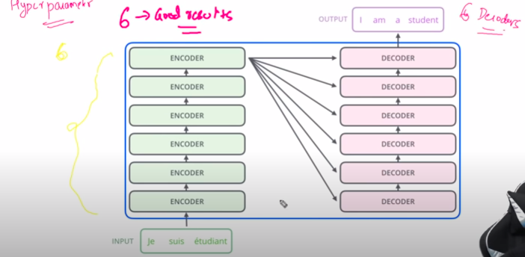
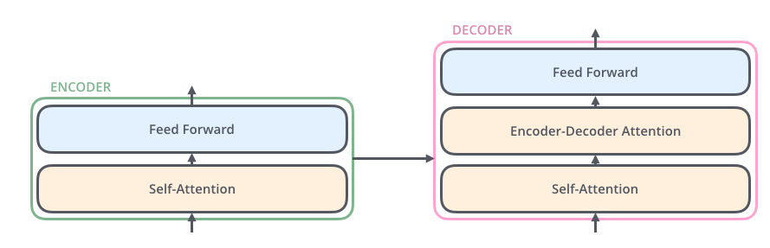

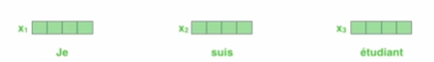
2. Each word is converted to vector of 512(hyperparamater) dimensions(based on research paper.
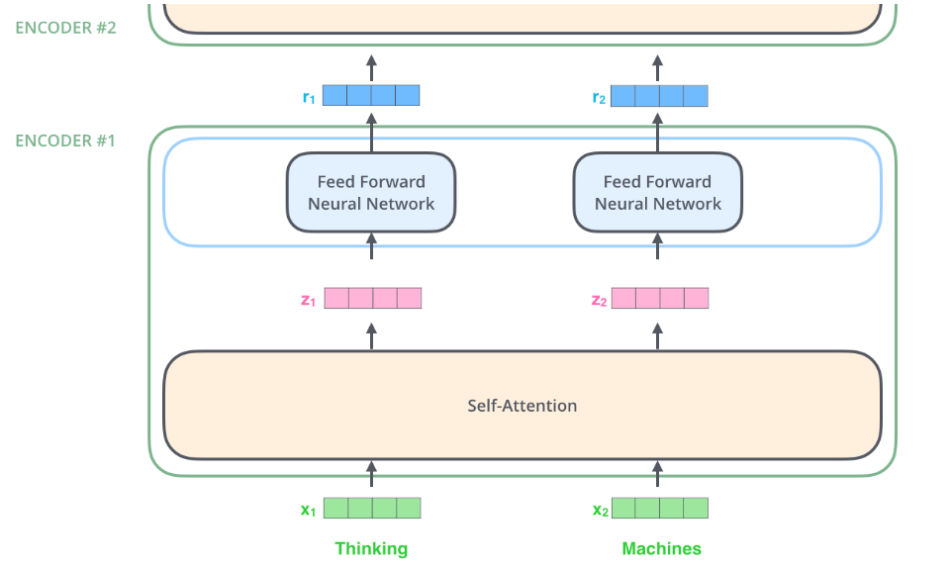
3: All words are converted to 512 dimensions vector at once and pass it as i/p to self-attention at once(same time). In RNN, we provide each word one by one based on timestamp.

Self-Attention Layer(Step 1-3)
Step 1:
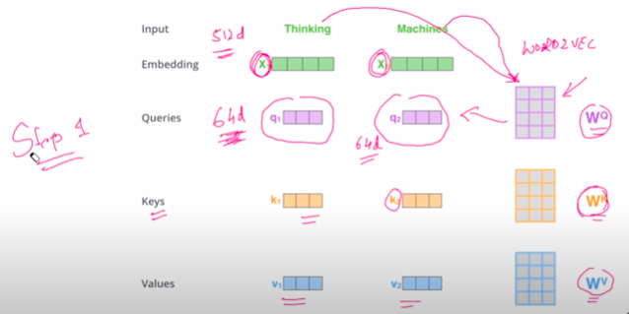
Word(Thinking & Machines) are passed to self-attention at same time & its converted to 512 dimensions(Hyperparameter) vector using Word2Vec in Embedding layer. Embedding layer(512D) is multiplied with weight(Wq) in queries to get 64D(Hyperparameter) vector. Vector in embedding layer is then multiplied by weights in Keys and Values to generate k1,k2 & v1,v2 respectively.
Wq, Wk & Wv – weights are updated in back propogation.

Step 2:
Queries & keys weight are multipled for each word. For word “Thinking” - q1*k1 & q1*k2. Same is done for word “Machine”(Written in marker) on right side.
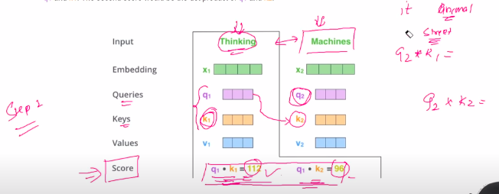
Step 3:
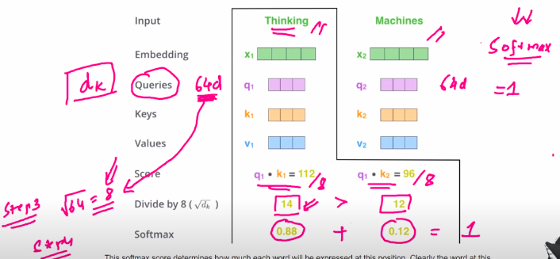
Score is divided by 8 which is square root of queries(64d) and then softmax activation function is applied
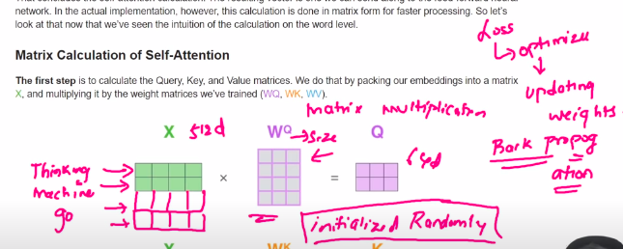
We are multiplying softmax with Value vector and o/p V1 & V2 is summed to get Z1 which is o/p of self attention layer and its i/p to Feed Forward Neural Network(FFNN)
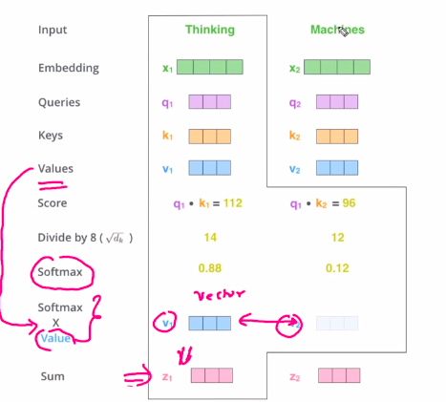

If we use 1 attention head, we apply same weight for all words. In order to provide importance to other words, v need to apply multiple attention heads. Optimal attention head is 8 as per research paper.
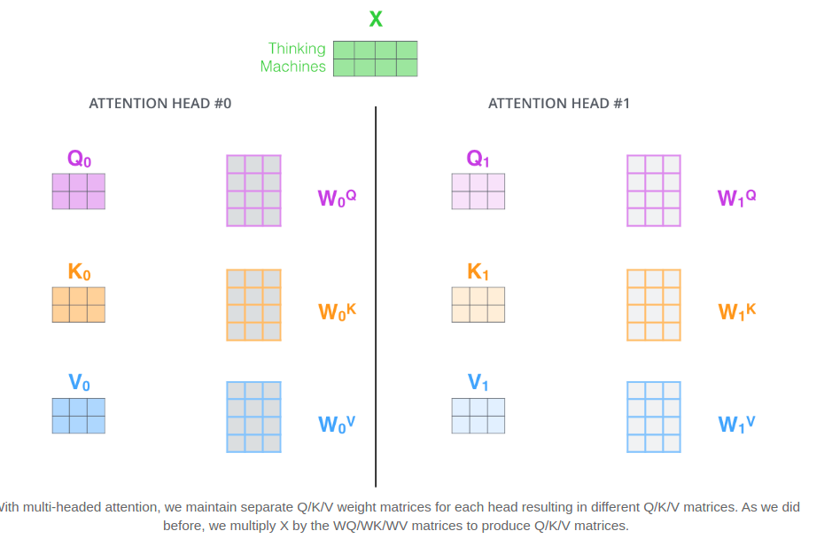
We will concat all head output(Z) and pass it to FFNN layer.
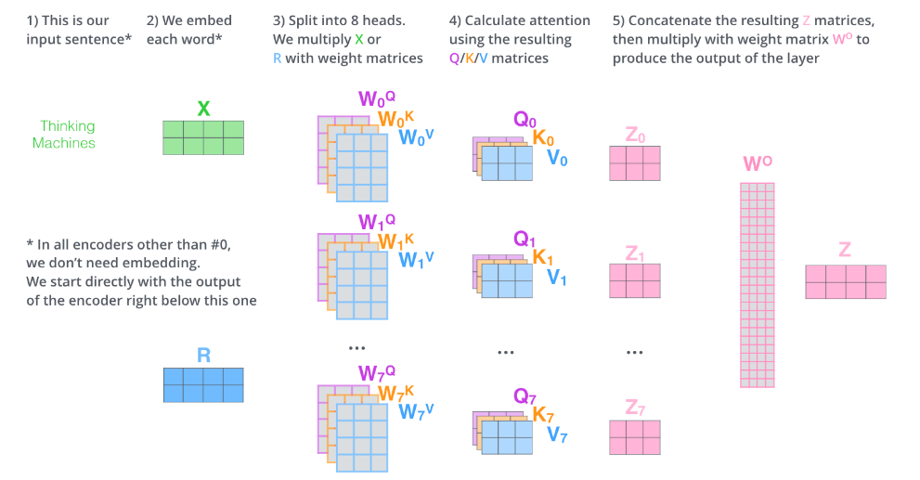
Before providing vector to Encoder, we apply positional encoding to find distances between the words(ordering of the word). Nearer words will have very small distance(“je” and “suis”). Far words will have more distance.
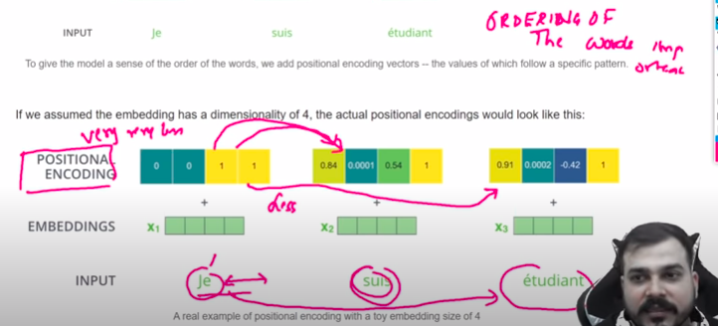
If some of words aren’t important then we will skip it and move to Add & Normalize.
Resnet: We will skip hidden layers if it isn’t important. Same happens here as well.
Add & Normalize: It is layer normalization
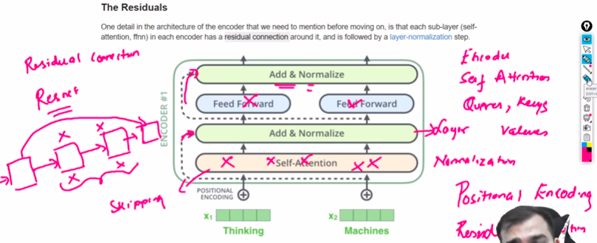
We pass all words at once from Encoder but decoder will generate words one by one. o/p of Encoder is passed to “Encoder-Decoder Attention” layer to all decoder & applied linear and softmax to generate 1st word. Generated word from decoder is again passed as i/p to decoder to generate next word.
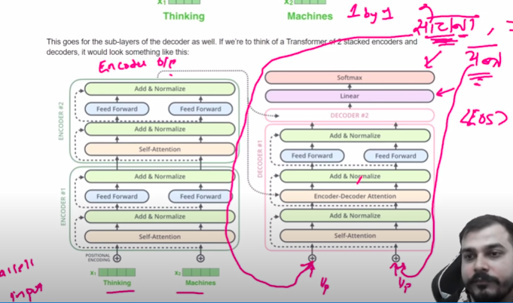
Encoder & decoder flow diagram is clearly available in transformer_decoding_1 & transformer_decoding_2 in /home/vinoth/Learning/Python/Images.
transformer_decoding_1 – Encoder gets all i/p at same time till End of Sentence(EOS) and apply encoding and pass the vector once to the decoder.
transformer_decoding_2 – Decoder generate word one by one & generated word is given as i/p again to the decoder.

LSTM VS Sequence to Sequence
When both input sequences and output sequences have the same length, you can implement such models simply with a Keras LSTM or GRU layer (or stack thereof).
In the general case, input sequences and output sequences have different lengths (e.g. machine translation) and the entire input sequence is required in order to start predicting the target. This requires a more advanced setup, which is what people commonly refer to when mentioning "sequence to sequence models" with no further context.

